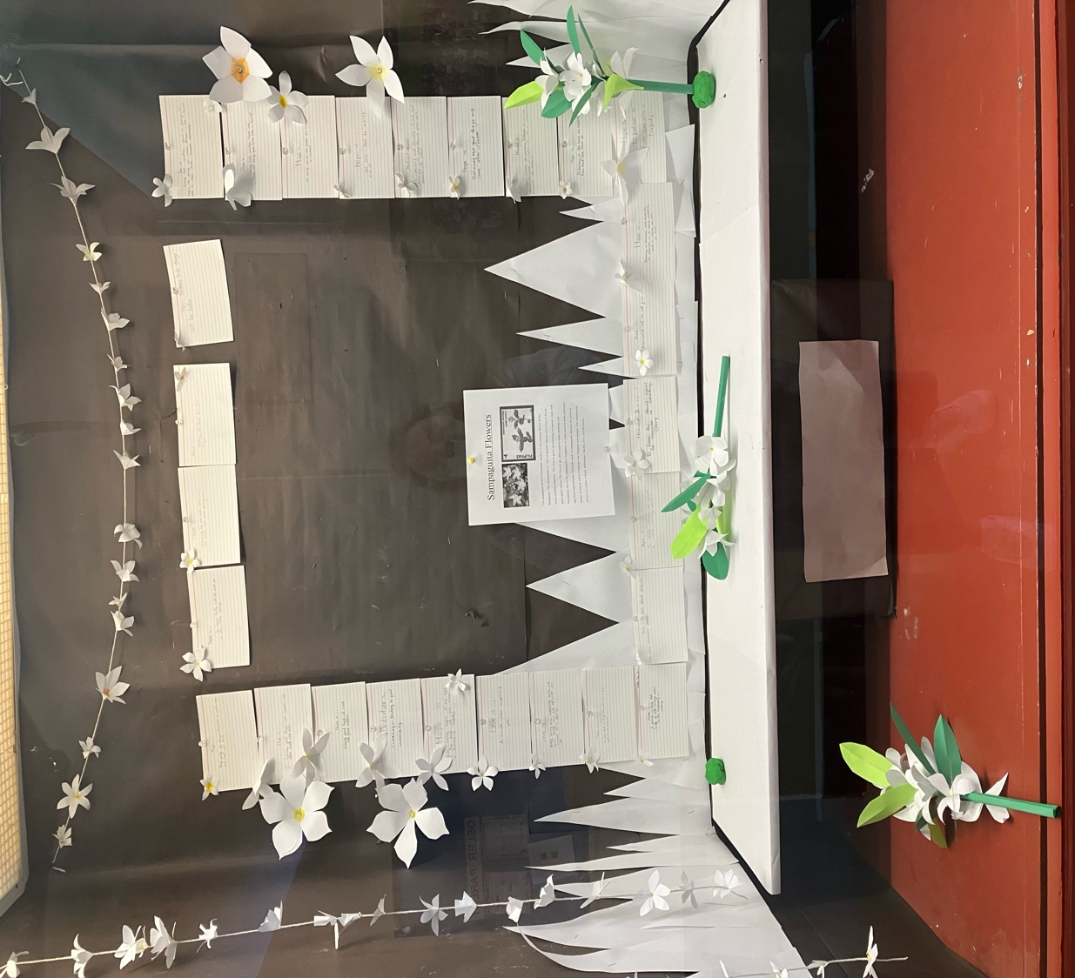

Our hearts go out to those impacted by the Lapu Lapu tragedy

Friday May 9, 2025

Good afternoon Osler community

Osler jerseys

Play Day next Friday on May 16

Earthquake Drill

Young Entrepreneur Fair!

Camp Summit

Osler students who are part of the sports teams (basketball, volleyball, track and field etc.)  throughout the year wear Osler jerseys.  We have jerseys to lend out, and you can also order a personal one to keep. If you wish to purchase an Osler jersey for your child, please follow the link below: <https://urstore.ca/stores/sir-william-osler-owls/products/kids/t-shirts/performance/atc-100-poly-easy-care-moisture-wick-t-shirt/y350/coal-grey/?ps=1&d=5444>



**The staff at Osler have planned a Play Day for Friday June 16.**

**Please read the following information:**

**Students will attend an assembly on Monday May 12th**

* All open areas both inside and out will be supervised throughout the Play Day times. Recess and lunch will remain regular supervision.
* While the classrooms will be open with access to activities, children are encouraged to bring items from home that they may want to play with as well. Items may include a board game, crafts, scooter (along with helmet), basketball, hockey equipment (along with goggles). All belongings from home will be the responsibility of the student.
* Absolutely **no electronic screen devices** will be allowed for this day. Bikes will also not be allowed on the school grounds for play. As with any school environment, **no violent toys**, such as Nerf guns or any other type of perceived weapon will be allowed. Remote control toys are acceptable.

✓ There will be a designated area outside to offer children the opportunity to bring their ‘wheels’ provided they have a helmet. Your child may want to be outside for most of the day, so please ensure that they are dressed for the weather.

Your child will begin the day in their classroom and end their day there as well. Drop off and pick up remain the same as any day.

Play days have been incorporated into schools throughout the world, and now a Global Play Day has been organized [http://www.globalschoolplayday.com/.](https://www.google.com/search?q=global+play+day+2025&rlz=1C5GCCM_en&oq=global+play&gs_lcrp=EgZjaHJvbWUqBwgAEAAYgAQyBwgAEAAYgAQyBwgBEAAYgAQyCQgCEEUYORiABDIHCAMQABiABDIHCAQQABiABDIHCAUQABiABDIHCAYQABiABDIHCAcQABiABDIHCAgQABiABDIHCAkQABiABNIBCDY0NDZqMGo3qAIAsAIA&sourceid=chrome&ie=UTF-8#:~:text=Global%20School%20Play,https%3A//globalschoolplayday.com) The day is an opportunity for children to explore play on their own accord.

To learn more about the importance of unstructured play in our society, please follow this [link:](https://www.google.ca/url?sa=t&rct=j&q=&esrc=s&source=web&cd=1&cad=rja&uact=8&ved=0ahUKEwjQ9N6s7DSAhUS%20%203mMKHSn4ABUQyCkIHDAA&url=https%3A%2F%2Fwww.youtube.com%2Fwatch%3Fv%3DBg-%20%20GEzM7iTk&usg=AFQjCNFI5gkZazEfJa8R69GG_JDJmILncw.)

We are very excited to provide this opportunity to the children. We hope that you will also engage in conversations afterwards.

**Earthquake Drill**

On Thursday the VSB conducted the District Big One @ 2:00 earthquake drill. Volunteer parents helped us with the reunification portion of the drill and our Building Engineer conducted a rapid damage assessment along with our SERT (School Emergency Response Team) updating inventory. The students were calm and comfortable during the drill and as last year the weather helped. Thanks to all who participated.

**Entrepreneur Fair**

Divisions 5 and 6 are ready to share their experiences with the community. Thank you to Ms. Kim and Ms. Feng for their continued work to ensure the success of this fair!

**Camp Summit**

Last month, Osler's grade 7 students had a wonderful four day trip to Camp Summit in Squamish. The students were lucky to have great weather for the entire duration of their stay. While at camp, they enjoyed many fun activities such as mountain biking, archery, and high ropes. This photo was taken on the last day of the excursion at Anderson Beach on the Squamish River.

I hope that all mothers enjoy a special weekend!

Rosemary Thomas

Principal at Osler