Friday May 30, 2025.

Good afternoon Osler community

Updated 2025- 2026 School Calendar

Leadership Spring-Cleaning sale June 5th

Drumming workshops

Track and Field District Final event

Fire-fighter and truck visit with Division 11

Volunteer Tea

**Updated School Calendar**

Please see last page for updated school calendar for next school year. The professional development day in September has been moved to May.

**Leadership Spring-Cleaning Sale!**

On Thursday, June 5th, the leadership team will be hosting a Spring-Cleaning sale to support **BC SPCA** and **Pancreatic Cancer Canada** from 3:00 to 3:30 PM after school by the Basketball Court. If that day has bad weather, we will change the location to the Owl Alcove.

**Drumming Workshops**

On Monday students participated in a school wide drumming presentation along with class workshops. The students learned a variety of rhythms from around the world using various pieces of equipment for instruments, including their body!

**Track and Field District Final event**

Churchill was the Osler’s site for the VSB District Track and Field meet. It was a beautiful day, almost too sunny! The athletes who participated were organized and gave it their all! Thank you so much to all the coaches who participated in the practices, mini meets and final meet! Thank you to Ms. Jackson, Ms. Shibata, Ms. Gill, Ms. Tayler, Ms. Earle, Ms. Beale Dala. Ms. Shirai, Ms. Angeles, Ms. Brady and Mr. Coutts.

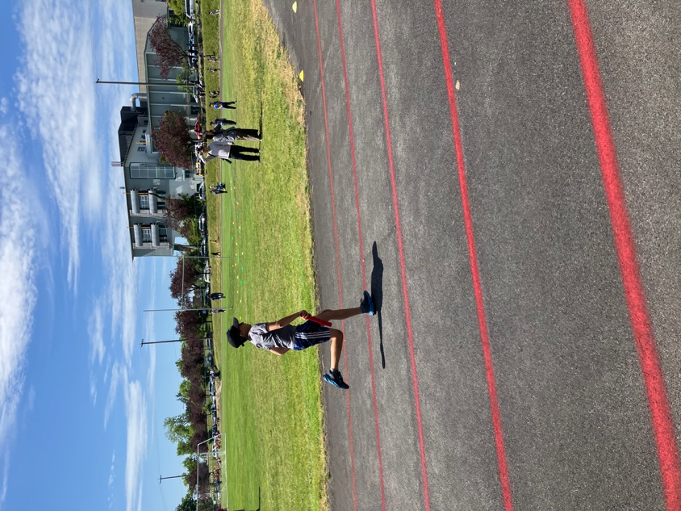 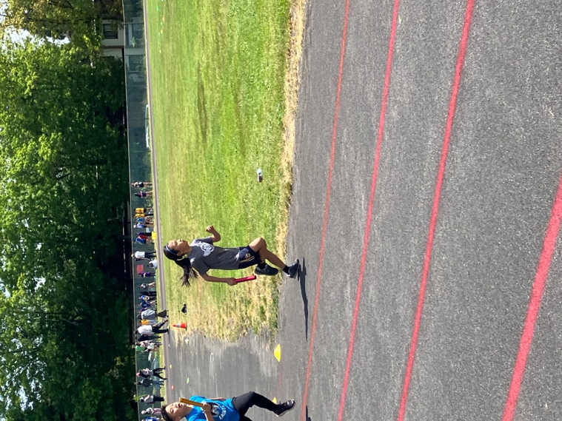

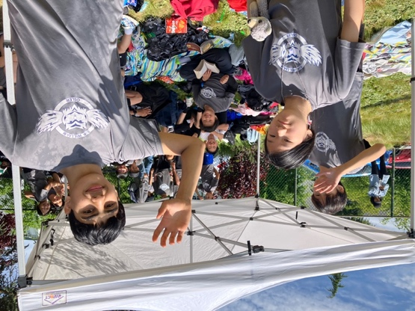

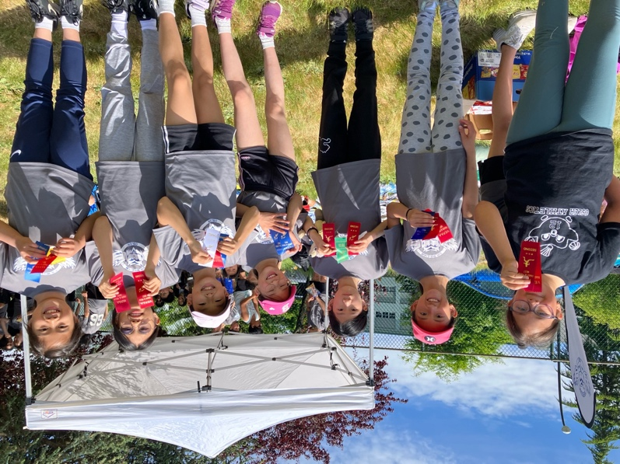

**Division 11 visit**

On Wednesday Ms. Sommer’s class was visited by the Vancouver Fire Department! Captain Patrick along with his crew Adam, Alyia and Joel brought along their fire truck and reminded the children about fire safety.

**Volunteer Tea**

We were so happy to see so many of our wonderful volunteers come out so that we could show our gratitude. Thank you for coming out and breaking bread with us!

**Osler Year-End Community Potluck**

**Friday June 6 at 3:00 - 4:30 pm**

Our first Community Potluck is next Friday and we’d love for you to be part of it. We’ve invited all Osler staff and teachers, as well as after-school care kids and YMCA staff, so it’s shaping up to be one giant year-end celebration!

We’re still looking for more families to help make our potluck table full and festive. Even if you’re not sure what to bring yet, just add your name so we know you’re on board. Whether it’s store-bought treats, packaged snacks or homemade favourites, everything is welcome and appreciated.

* Sign up to bring food:  
  <https://docs.google.com/spreadsheets/d/1sM3OZhg2Ob7laQ0F9tX4-RaCA03aThpA/edit>
* Sign up to volunteer:  
  <https://docs.google.com/spreadsheets/d/1lv0xRj8lbodeRXAsjupZcZ5P38MiSjXZ/edit>
* Next Friday, please drop off your food with a Greeter at a table in the Undercover Area (by the basketball courts) between 2:50-3:10 pm. Have questions or trouble signing up? Email us at [oslerpac@gmail.com](mailto:oslerpac@gmail.com) and we'd be happy to help.

Can't wait to see you there!



Enjoy your weekend,

Rosemary Thomas

Principal at Osler