χpey̓ Elementary School
Code of Conduct
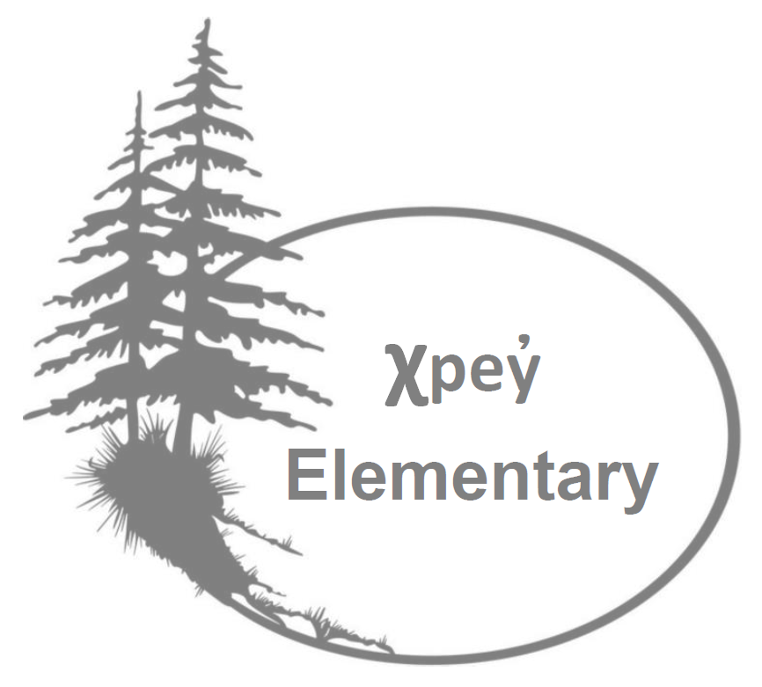

Statement of Purpose
χpey̓ Elementary is committed to uphold a safe, inclusive, equitable, welcoming, nurturing, and healthy school environment.
Through the lens of the Medicine Wheel, a symbol of healing, growth, life, learning and balance in many Indigenous nations, χpey̓ Elementary views students as wholistic beings, and enthusiastically endeavors to assist students in growing in the four quadrants of their being: mental, physical, emotional, and cultural. As such, our Code of Conduct fosters growth in all life areas and is applicable to pay̓ Elementary community members of all life stages. These expectations apply to behaviour at school, during school – organized or sponsored activities – and behaviour beyond these times (including online behaviour) that negatively impacts the safe, caring, and orderly environment of the school and student learning.
- Promote clear behavioural expectations of respectful and responsible citizenship that led to a culture of safety, caring and respect amongst everyone in the school and programs and at all school-events and activities.
- The School Code of Conduct applies at school, during school-organized or sponsored activities, on school buses, and any behaviour even if outside of school or school hours, (including on-line behaviour), that negatively impacts the safe, caring, or orderly environment of the school, and/or student learning.
Conduct Expectations

- Acceptable Conduct
- Respecting self, others, and the school
- Contributing to a safe, caring, positive, inclusive, and peaceful environment
- Seeking to prevent violence and potentially violent situations and demonstrating social responsibility by reporting such situations.
- Engaging in purposeful learning activities

- Unacceptable Conduct
“Students shall not discriminate against others on the basis of Indigenous identity, race, religion, colour, ancestry, place of origin, marital status, family status, age, sex or sexual orientation, gender identity/expression, or physical or mental disability, or for any other reason set out in the Human Rights Code of British Columbia, nor shall a student publish or display anything that would indicate an intention to discriminate against another, or expose them to contempt or ridicule, on the basis of any such grounds.” Racism and discrimination will not be tolerated in our school.

- Behaviours that interfere with the learning of other, interfere with an orderly environment, or create an unsafe environment.
- Acts of bullying, harassment, intimidation, or physical violence
- Illegal acts, such as possession, use or distribution of illegal or restricted substances.
- Theft or damage to property
- Behaviour involving physical force intended to hurt or damage others.
- Communicating disrespectfully either verbally or with body-language
- Willful destruction or damage to property
- Inappropriate internet use
- Creating unsafe conditions
- Interfering with the learning of others
- Inappropriate dress (clothing communicating offensive words or images / clothing that depicts or references
- restricted substances)
- Possession, use, or distribution of illegal or restricted substances
- Possession of real or fake weapons. “Anything that is commonly used or designated to hurt someone or to put someone in fear” – VSB policy.
PROHIBITED ITEMS
The following items interfere with or create unsafe conditions for our community and are prohibited from school grounds and school organized or sponsored events.
- Weapons – fake or real
- Illegal or restricted substances
- Lighters
- Fireworks or firecrackers

Please do not send toys, valuable or expensive items to school. χpey̓ Elementary
Note: Behaviours (both acceptable and unacceptable) cited in the code of conduct are examples only and not an all-inclusive list.

- Rising Expectations
Students are expected to learn and mature as they move through successive grades, and as such the expectations progress towards increasing personal responsibility and self-discipline, as well as increasing consequences for inappropriate conduct/unacceptable behavior.

- Retaliation Prevention
All reasonable steps will be taken to prevent retaliation against a student who has made a complaint of a breach of a code of conduct.
Consequences
- Disciplinary action, wherever possible, is restorative rather than merely punitive. The school will treat seriously any behaviour that discriminates based on Indigenous identity, race, religion, colour, ancestry, place of origin, marital status, family status, age, sex or sexual orientation, gender identity/expression, or physical or mental disability.
- Repetitive or severe unacceptable behaviour may result in increased severity of subsequent disciplinary action. The age and maturity of students are considered when determining appropriate consequences.
- Special considerations may apply to students with special/diverse needs if these students are unable to comply with a code of conduct due to having a disability/challenge of an intellectual, physical, sensory, emotional, or behavioural nature.
- Responses to unacceptable conduct are consistent and fair.
- Students, as often as possible, are encouraged to participate in the development of meaningful consequences for violations of the established code of conduct.

- Notifications
The principal or designate has a responsibility to inform other parties of serious breaches of the code of conduct. These parties include:
- Parent(s) of student offender(s) and parent(s) of student victim(s) – in every instance
- School district officials
- Police and/or other agencies, as required by law.
- School community, when deemed necessary, to reassure members that school officials are taking appropriate action.

- Suspensions
In accordance with the School Act, Sec. 85 (2) (ii) and (d), the Board authorizes the principal or designate of any school in the district to suspend a student from attendance at school for up to five days.
Suspensions may be for the following reasons:
- because a student is willfully and repeatedly disrespectful to a teacher or to any other employee of the Board carrying out responsibilities approved by the Board.
- because the behaviour of the student breaches the District Code of Conduct or other policy and/or has a harmful effect on others or the learning environment of the school.
- because the student has failed to comply with the School Code of Conduct.

Suspensions over five days are made in consultation with the appropriate Director of Instruction as per District Student Code of Conduct, AP 350.
As per AP 350 7.7 an educational program must be provided.

