Kindergarten registration for children born in 2021 begins on November 1
All kindergarten applicants are required to complete an online application for their English catchment elementary school. This includes families who wish to apply for District Choice programs (Early French Immersion, Montessori, Indigenous Focus School, Early Mandarin Bilingual, Nootka Fine Arts) and/or make a cross boundary application to attend a non-catchment school.
The priority registration period for kindergarten opens on November 1 and closes on January 31. Students who submit an online application within this priority period will be accommodated before late applicants.
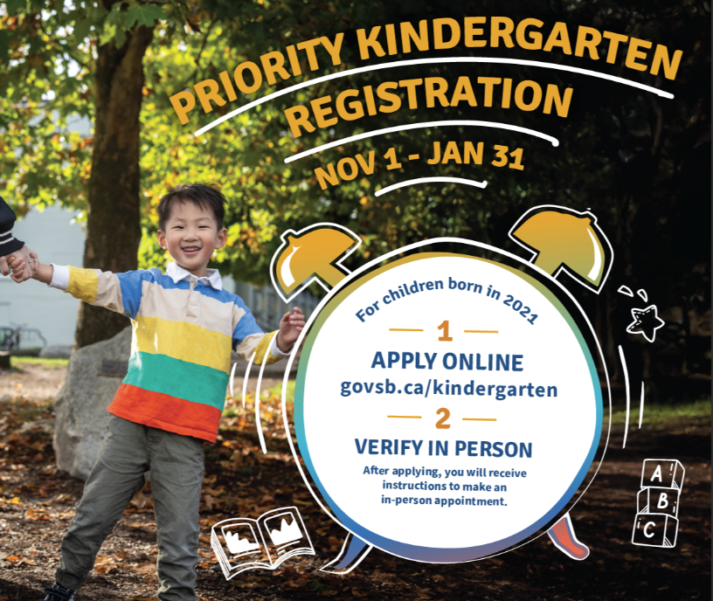
Applying for kindergarten is a 2-step process:
Step 1: Online Application (ApplyNow)
- Completion of an online application form (https://applynow.vsb.bc.ca/) for the school year 2026-27
Step 2: Verification of documentation
- After applying, you will receive instructions on how to schedule your in-person appointment.
- Bring supporting documentation during your scheduled appointment for verification.
Supporting documents needed:
- Proof of residence in Vancouver
- Child’s birth certificate
- Immigration documentation (if applicable)
- Immunization records
- Court orders/documents (if applicable)

If you want to apply for a District Choice Program or cross boundary, you must first apply to your English catchment elementary school. District Choice Programs and cross boundary applications will be accepted in early 2026. For more information, go to: govsb.ca/kchoice and govsb.ca/crossboundary

In the event there are more in-catchment applicants than available space* at the school, the following process will be used to prioritize enrolment:

Kindergarten Applications Received Between November 1 and January 31
- In-catchment kindergarten applicants with siblings in attendance at the school (and who will be attending next year) will be placed first.
- The names of all other in-catchment registrants will be entered into a random draw for the remaining kindergarten spaces.
- Students who cannot be accommodated will be placed on a waitlist in the order in which their name was drawn.
- In the event there are more in-catchment registrants than can be accommodated at their catchment school, students will be placed at another school as close to the catchment as possible until space becomes available.

Kindergarten Registrations Received AFTER January 31st
In-catchment kindergarten students who apply after January 31 will be accommodated if there is space. If there is no space, their names will be added to the bottom of the existing waitlist.
Note: Sibling priority does not apply for registrations received after January 31.
In the event there are more in-catchment registrants than can be accommodated at their catchment school, students will be placed at another school as close to the catchment as possible until space becomes available.

For more information on kindergarten registration visit the VSB website: govsb.ca/kindergarten
* Available Space includes physical capacity, resources, staffing, or educational programs available or planned for a school as defined by the District (Administrative Procedure 300).

