SEXSMITH PAC MEETING - April 27th, 2022• 6:26pm –7:40pm in the library at Sexsmith

EXECUTIVE
Co-Chairperson: Mandeep Sidhu (absent) / Deljit Beesla
Treasurer: Novella Lui
Vice-Chairperson/Hot Lunch Coordinator: Mike Atwal
Secretary: Jacqui Crawford
Fundraiser: Lana Wong
Member at large: Eva Jung

GUEST
Principal: Ms. Laura Rhead

MEETING MINUTES
Deljit called the meeting to order at 6:26pm.

- Quorum was met – 9 members present
- Introduction and welcome statement and Indigenous Land Acknowledgement: We are grateful to be working together on the traditional, ancestral, and unceded territories of the xʷməθkʷəy̓əm|Musqueam, Sḵwxwú7mesh|Squamish & səlilwətaɬ |Tsleil-Waututh Nations
- Approval of agenda (no additions): Lucia and seconded by Mike.
- February 23, 2023, PAC Meeting Minutes approved by Mike and seconded by Lana.

- Principals Report
Indigenous Land Acknowledgement: We are grateful to be working together on the traditional, ancestral, and unceded territories of the xʷməθkʷəy̓əm|Musqueam, Sḵwxwú7mesh|Squamish & səlilwətaɬ |Tsleil-Waututh Nations
Staffing updates:
- welcome to Ms. Stephanie Lynch, classroom teacher for Div. 7 (Ms. Pearce on leave)
- welcome to Ms. Vanessa Callaway, classroom teacher (with Ms. Spiteri) for Div. 14 (Ms. Wong on leave)
- new staffing information will be shared with PAC executive soon, regarding planning for 2023-2024
Please note recent news in our April newsletter online: https://sway.office.com/99adkJVJMr3c5nc9?ref=email
Any newsletter feedback is welcome!
Thank you to parents who provide photos for us. A reminder that photos and videos taken on school property cannot be shared via social media without the permission of those in the images. Thank you! We certainly love all the photos for our internal, year end slide show. These photos are kept with the principal and will be deleted after use in June 2023.
Coming Up:
- Onsite programs: Yoga, VPD/ICBC, HUB Cycling, PLEA, various volunteers! Punjabi school inquired but did not book yet. Ideas? please share…
- Volunteers needed for May 15 Heritage Fair if you are interested- please contact dconrad@vsb.bc.ca
- Monday, April 17- lockdown drill
- Friday, April 28- VPD Pedestrian safety talks and distracted driving campaign assemblies K-3 & 4-7 (am)
- Wednesday, May 3- fire drill
- Thursday, May 4- 2pm VSB District-wide Earthquake Drill **volunteer families needed for 'reunification practice'
- Thursday, May 4- 3:30pm-8pm PAC Family Photo night! SOLD OUT
- Monday, May 8- VCH Immunization Clinic
- Tuesday, May 9- CLASS PHOTOS
- Friday, May 12- Student Council spirit day: "Fan Day/Jersey Day”
- Wednesday, May 17- Gauss Math Contest
- Friday, May 19- SPORTS DAY—PAC volunteers needed (fruit station? classroom teacher support)
- May 26- Filipino Festival! **Are you interested to volunteer? Please contact: Au at 604-441-7442 or Girlie at 778-869-4430.
Looking Ahead:
  - Emergency drills- how do the staff prepare? Want to know more? Come and be part of the ‘reunification process’ at 2:15pm Thursday, May 4- volunteer by emailing sexsmith@vsb.bc.ca
  - Our school is currently FULL. We will not be able to confirm placements until May when we are given our VSB staffing amounts. We hope to accommodate all catchment students, but this may not be possible. Priority is given to siblings wherever possible, as well. We currently have over 50 SXS students placed at other schools due to overwhelming numbers of new students in our neighbourhood. We have confirmed 3 kindergarten classes for next year, but likely still with 18 divisions due to lack of space for expansion.
  - PLEA has offered free online safety workshops for our grade 4,5,6,7s (booked by the classroom teachers at various times) and I have inquired about their parent session for PAC- looks like a great option for us! https://www.plea.ca/prevention/children-of-the-street/ We can book either in September, or November for an in-person parent night- large group style in the gym. Thoughts on dates? Conferences will likely be set around Oct 23-Nov 3 and again around Feb. 5-16
  - The calendar for next school year has been finalized with a few updates across VSB (conference and report dates (3 reports, 2 conferences), Pro D still TBA and will be finalized in May (see handout)
  - School learning plan/goals/visioning is ongoing around the themes of Indigenous Education enhancement and creating a Sense of Belonging for all. How can we further develop a sense of belonging for all parents? What could we START doing, STOP doing, KEEP doing?

Funding Opportunities
- We will continue to prioritize and select school funds where necessary for the following items in the remainder of 2022-2023, but please consider these ongoing areas for funding:
- Playground equipment- new apparatus for the lower playground- Rotary may be interested in a community build
- More game lines and beautification along the primary wing outside corridor/paving stone project (high quality paint needed)
- Technology- mounted projectors in each classroom (so far requested by 11 teachers; $1700 each), replacement and new laptops to create another cart (1200 each)
- soccer goal posts (now installed paid by school funds but seeking support)
- tarps and other ‘supplementary’ equipment for emergency use
- ongoing support for families with hot lunch program
- folding chair stacks and carts for the gym?
- field trips and experiences $/child is much appreciated, anytime!

- Treasurer’s update - Novella
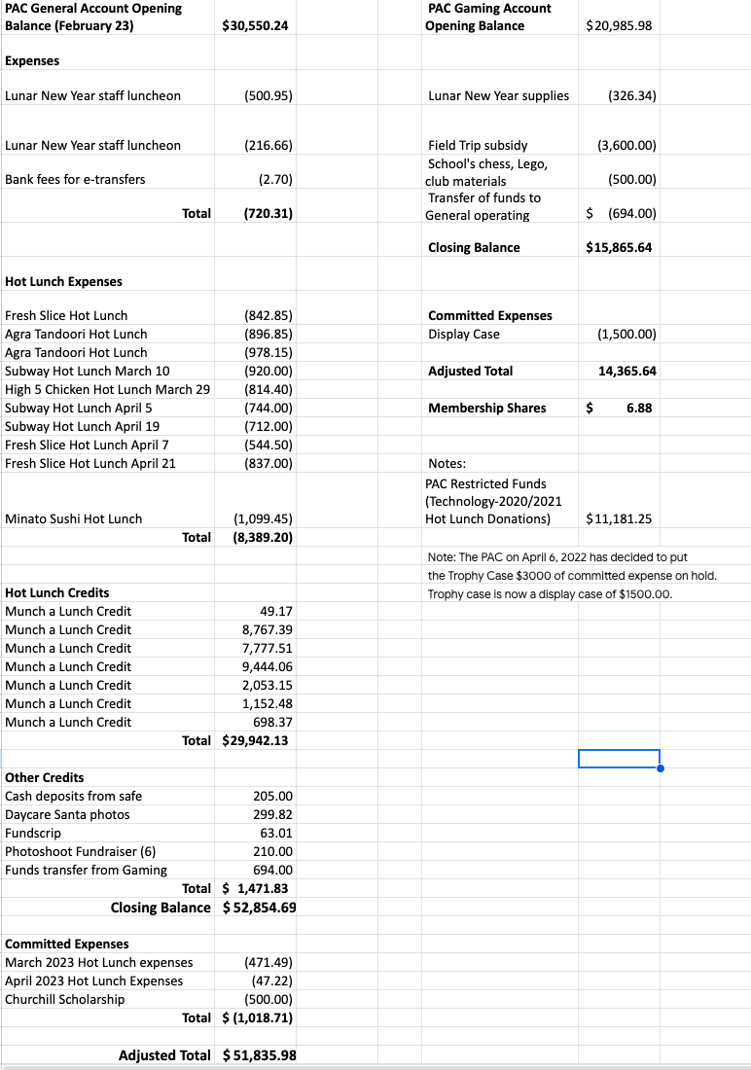

- Currently our operating account balance is $52 854.69
- We collected $29 942.13 from our hot lunch program,
- We spent $8389.20 for hot lunch expenses.
- $528 for juice and chips that Pandora purchased towards hot lunches.
- Profit was $11 853.
- We will be donating a $500 scholarship for a previous Sexsmith student that is attending Churchill.
- Adjusted total $51 835.98
- $3150 to school classroom and teachers funds.

Gaming Account
- $3600 given to Laura for field trips/events subsidies.
- $500 for chess and lego supplies
- $694 was transferred out of the gaming account and into the operating account. Previously monies from Chocolate and Landyard fundraisers were deposited in error to the gaming account.
- Pandora’s lunar supplies were also cleared
- Closing balance $15 865.64
- We have committed funds of $1500 towards the display case
- Adjusted total is $14 365.64

Additional note: 2020-2021 before pandemic we have $11181.25 from operating account restricted for the technology.

Distributing funds - Deljit
- $15 000 for expenditure
- Deljit met with Laura to discuss funds
  - Mounted projectors - without the PAC funding it would take 4-5 years to provide a projector for each classroom (Laura can fund up to 4 this year.) If the PAC bought 8 at $1700 each, then $13 600 of the tech funds set aside would be used. Laura explained how different the classroom space is when using mounted projectors, it allows for more movement around the classroom and enables a different style of teaching environment.

- We could make the laptop cart a long term 1-2 year plan. If we invest in an Apple laptop cart it costs $37000, if we buy a Dell laptop cart it costs $24 000. The school already uses Apple, it would be preferable to keep them all Apple. Looking at the hot lunch profits, if we continue twice a week for 3 terms, for 2 years we could reach this goal.

- Motion put forth by Deljit to fund 8 mounted projectors, seconded by Lucia.
- We will commit to the 2 year plan for laptops and carts

- Hot Lunch Coordinators Report (Mike)
- Hot-lunch has moved to 2 times a week for this term, it is only possible because of the volunteers. The current volunteers have been participating in Hot Lunches since the start of the school year. There are, however, days that not every volunteer can show up and then we are hoping we have enough people on the day to organize and distribute. We can't do the Hot Lunch Program without the volunteers, so we desperately need more volunteers. (It was suggested to for someone from the PAC come and help recruit new PAC volunteers at the Welcome to Kindergarten event.)
- The vendors are going ok, Hi-five not the greatest again, we give the vendors feedback.
- Hot lunch will be cancelled on the field trip days.
- Novella spoke about the healthy choices of the VSB food guidelines, a food framework approved by the District VSB. We will conduct a study for parents' feedback about choices towards the end of next month.
- The food framework is approved by District PAC and there is federal funding for universal school meals, so this may impact hot lunches in the future.
- Laura will put the survey together, once the PAC has submitted questions.
- Grade 7 helpers with Hot Lunch is working really well
- Laura suggested that every class could have a hot lunch student rep and a rotating parent rep for class.

- Fundraiser Report (Lana)
- Photo Day - organized by Pandora. We had 18 slots and they sold out on the first day. It was $35 a time slot, minus bank fees and munch-a-lunch fees, profits raised $615.48. It was a good fundraiser and we will run it again, maybe in November in time for Christmas.

- We missed the deadline for the planters/flower baskets, we may use Vandula Farms for a future fundraiser.

- Lana contacted the chocolate almond fundraiser vendor (World’s Finest Chocolates) and the prices did not go up from last year. The chocolate almonds are still $31.80 per box. There is an option to sell $2 - 55g packages or $3 - 75g, we will stick with the $2 packages. We will order more than last year and we will continue with the chocolate almonds. We will get free shipping if we order by June 15, we can change the order 2 weeks prior to the shipping date. We get two 5lb chocolate bars free. We also got 10 free cases last year, Lana will look into that.

- On-going fundraisers.
Fundscrip.
    - PAC Gift Card Fundraiser Gift cards are the perfect gift but can also be used to pay for things that you would have used cash for and you can help support your child’s school when you buy one!
    - Shop from the comfort of your home when you purchase gift cards through Fundscrip, and Sexsmith will receive a percentage of the gift card sale.
    - Choose from over 100 popular retailers like Toys R Us, Gap, Cineplex, Metropolis at Metrotown etc. Please use this link: https://www.fundscrip.com/Sign-Up.aspx?IID=2CBHHR
Oliver Labels
    - Keep your items out of the lost and found pile by labelling your personal items with Oliver's labels. Custom labels can be printed with your child's name to use on all their belongings. When you purchase labels from Oliver's Labels, 20% of the purchases will support Sexsmith PAC's fundraising efforts. Please use this link; http://www.oliverslabels.com/sexsmithelementary

- PAC has set up an account with Return-It Express.
  - Visit any Return-It-Express location. Find a location here.
  - Bring your rinsed refundable containers in a sealed, clear plastic bag.
  - Enter the account number 604-713-4901 (school’s phone number) into the Express kiosk and print out the number of labels you need.
  - Tag each bag with a label and drop the bags off in the designated Express drop-off area.
  - Funds collected will be credited directly to the Sexsmith PAC account to benefit the school.

- BUY BREAD, EAT FRESH, GIVE BACK!
The Sexsmith Parent Advisory Committee has partnered with COBS BREAD at 2924 Main St.
- Effective January 27, 2023, all items purchased by members of the Sexsmith community will raise money for our school PAC!
- When you are at COBS, before you pay for your baked goods, let them know you are a part of the Sexsmith school fundraiser and 5% will be donated back to our school PAC.

- New business
- Sports Day
  - freezies (primary freezies were bought on sale last year
  - Lana will pick up the larger freezies
  - No bottles of water this year, last year the kids got confused as all the water bottles look the same. This year kids will bring their own water bottles
  - Laura suggested a fruit station, maybe 2 parents per class to support fruit station
  - Sports Day will look similar to last year - Grade 7 students will help out
  - Primary divisions will go to Winona Park
  - Pizza for hot lunch on Sports Day, reminder to parents to order pizza

- Filipino Fiesta -May 26th
- Are you interested in volunteering? Please contact: Au at 604-441-7442 or Girlie at 778-869-4430.
  - volunteers needed
  - vendor is picked for teachers luncheon
  - superstore has donated the food items

- Fun fair - June 9th
  - Lana and Lucia will help with the organisation of the Fun Fair.
  - PAC executives had concerns about volunteers and the short time to organise it.
  - $2000 - original budget for the fun fair
  - We would sell tickets for food and games to cover the costs. This is a zero profit event
  - Plan needs to be executed by the end of the week.

- Volunteer appreciation tea - June 14th in the library

- The next PAC meeting is set for Thursday May 18th at 6:15pm. The meeting will be held at the library.
- Future meetings scheduled on AGM Jun 22 2023.
- Meeting adjourned at 7:40pm

