SEXSMITH PAC MEETING

February 23rd, 2022• 6:30pm –7:39pm in the library at Sexsmith

EXECUTIVE
Co-Chairperson: Mandeep Sidhu / Deljit Beesla (absent)
Treasurer: Novella Lui
Vice-Chairperson/Hot Lunch Coordinator: Mike Atwal
Secretary: Jacqui Crawford (absent)
Fundraiser: Lana Wong
Member at large: Eva Jung

GUEST
Principal: Ms. Laura Rhead

MEETING MINUTES
Mandeep called the meeting to order at 6:30pm.

- Quorum was met – 15 members present
- Introduction and welcome statement and Indigenous Land Acknowledgement: We are grateful to be working together on the traditional, ancestral, and unceded territories of the xʷməθkʷəy̓əm|Musqueam, Sḵwxwú7mesh|Squamish & səlilwətaɬ |Tsleil-Waututh Nations
- Approval of agenda (no additions): Deljit and seconded by Eva.
- January 23, 2023, PAC Meeting Minutes approved by Mandeep and seconded by Deljit.

- Treasurer’s update - Novella balance
- The last month’s balance is $33 137.52
- Cheques cleared for Breakfast with Santa and Hot Lunches.
- We got credit back from Munch-a-lunch $6891.60, that was for 4 hot lunches.
- Our current balance is $30 483. 97
- We are still waiting for some cheques to clear, one for Munch-a-Lunch and one for Lunar NY.
- Adjusted total is $28 869.51

Gaming Account
- We had a $694 cash deposit that was sitting in the office for some time, from Breakfast with Santa.
- We provided a cheque to Laura for the field trip subsidy for 18 divisions amounting to $3600.
- The display case cost $1900, PAC agreed to subsidise $1500 towards the trophy/display case.
- The Lunar New Year celebration cheque still needs to clear.
- The adjusted total is $15 566.20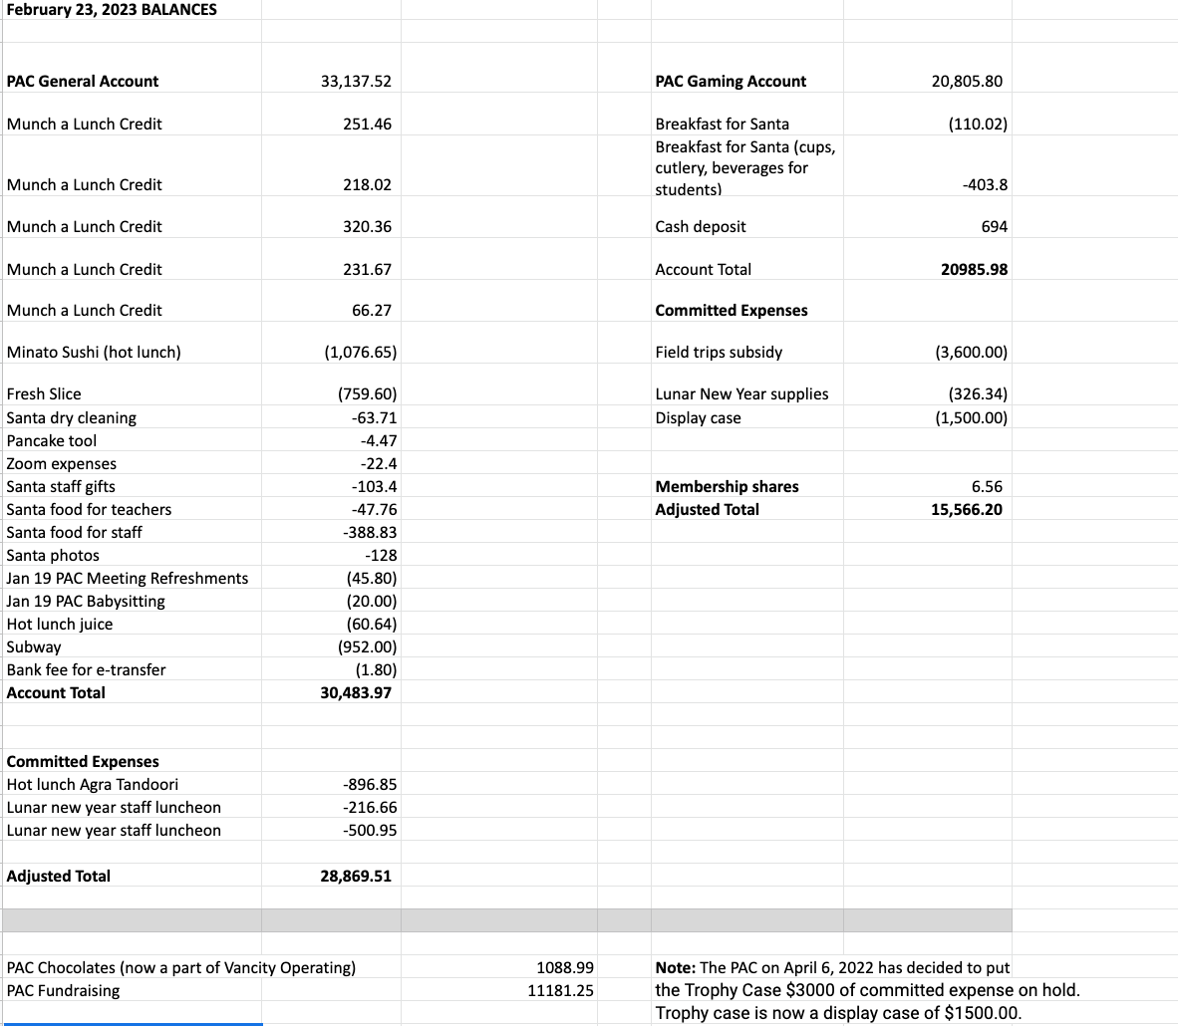

- Principal’s Report - (Ms. Laura Rhead)
- Indigenous Land Acknowledgement: We are grateful to be working together on the traditional, ancestral, and unceded territories of the xʷməθkʷəy̓əm|Musqueam, Sḵwxwú7mesh|Squamish & səlilwətaɬ |Tsleil-Waututh Nations
- Staffing updates: This month we are saying farewell to two support team members: Ms. Leah Williams is retiring from the VSB and Mr. Leni Loconte is moving to the secondary level to work in a special program at John Oliver. While we are very sad to say goodbye, we also wish them both well in these new chapters! We welcome Mr. Lalli Parmar as a substitute SSA and we will have two postings for new support staff coming up.
- Please note recent news in our February newsletter online:
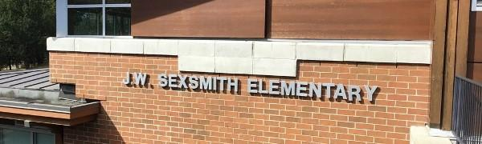
Sexsmith Elementary Newsletter February 2023
February Updates
Go to this Sway

- Any newsletter feedback is welcome!

- Thank you to parents who provide photos for us. A reminder that photos and videos taken on school property cannot be shared via social media without the permission of those in the images. Thank you! We certainly love all the photos for our internal, year end slide show. These photos are kept with the principal and will be deleted after use in June 2023.
- Current Highlights!
  - the Sr. Basketball teams continue to shine with thanks to our head coaches Mr. Biln and Mr. Kay! Thank you to all the parent drivers and supporters on the sidelines- it means so much to the kids.
  - hot lunch Fridays! A HUGE thank you from the students for the efforts of all parent volunteers, and parents who are ordering
  - professional development themes continue… anti-racism teaching and learning; creating a ‘sense of BELONGING’ for all students, and community members, at Sexsmith. This work is done not just on Pro
  - D days but also in our Staff and Staff Committee meetings. Next one- Feb. 28 8am
  - student council and student leadership- social justice club, peer helpers, library monitors, lunch monitors, school patrol, assembly leaders, PAC babysitters- amazing kids!
  - …upcoming spirit days to know:
  - -Thursday March 9 Green Day (wear green)
  - -Friday April 14 Retro Day (a decades day idea -- kids working out details)
  - -Friday May 12 Cosplay Day (our updated take on Superhero Day!)
  - -Friday June 16 Beach Day (dress for the beach)

  - Coming Up:
  - March 6-10: BOOK FAIR! **thank you to those parent/guardians who have offered- please contact our teacher-librarian directly if you can help, Ms. Aujla: gaujla@vsb.bc.ca
  - Feb. 21-24 - African Dance Workshops at SXS for K-7!
  - Feb. 22- PINK DAY! (read about Pink Shirt Day here)
  - Feb. 23- PAC Meeting @6:15pm in the library- childcare available
  - Feb. 24- Afro-Dance performance in the gym- time TBA but likely 2:00pm
  - March 1- Intermediate Science Celebration! 2-3pm; 5-6pm
  - March 6-10: SXS Scholastic Book Fair in our library!
  - March 8 & 9: EARLY DISMISSAL @2pm for conferences (spring conference week March 6-10)
  - SPRING BREAK: March 11-26
  - Back to school: March 27
- Looking Ahead:
  - Our school is currently FULL. We will not be able to confirm placements until May when we are given our VSB staffing amounts. We hope to accommodate all catchment students, but this may not be possible. Priority is given to siblings wherever possible, as well. We currently have over 50 SXS students placed at other schools due to overwhelming numbers of new students in our neighbourhood. We have confirmed 3 kindergarten classes for next year, but likely still with 18 divisions due to lack of space for expansion.
  - PLEA has offered free online safety workshops for our grade 6/7s (booked by the classroom teachers) and I have inquired about their parent session for PAC- looks like a great option for us! https://www.plea.ca/prevention/children-of-the-street/ May? Sept?
  - We are confirmed with Saleema Noon for an online parent presentation about body science and sexual health: 6:30pm on Zoom, April 12. Student sessions follow on April 13/14 at school: https://www.saleemanoon.com/wp-content/uploads/2022/05/Body-Science-Elementary-Workshop-Outlines-2022.pdf
- Funding:
  - PAC support and consideration for funding in various areas is so appreciated. Have you seen the new art display case and board outside the music room/gym? Take a look- thank you for this generous legacy item! Total cost was $1900- slightly above our estimate of $1500 but well under the original amount planned. THANK YOU! Most classes have also already accessed the $200/class for fieldtrips- thank you for supporting our enhanced programming.
  - We will prioritize and select school funds where necessary for the following items in the remainder of 2022-2023, but please consider these ongoing areas for funding, in addition to the class discretionary funds, resource teacher funds and library/music funds:
  - Playground equipment- new apparatus for the lower playground- Rotary may be interested in a community build
  - More game lines and beautification along the primary wing outside corridor
  - Endless opportunities with tech- mounted projectors in each classroom (so far requested by 11 teachers; $1700 each)
Sincerely,
Laura Rhead: lrhead@vsb.bc.ca

Questions: What about the photos on the Facebook Page? Ms. Rhead was not aware there was a FB page. It was discussed that no photos should be on that page and should we maybe close the FB PAC Account.

- Hot Lunch Coordinators Report (Mike)
- We added 2 new vendors for this term Minato Sushi which has been a great hit and Agra Tandori was good too.
- We cycled through the core vendors. The highest price point was $4.50 for butter chicken.
- Fresh Slice doubled up on orders, there was a mix up and we didn’t get charged for it.
- Subway was better this time using a different Subway vendor.
- The volunteers are doing well
- Mike is helping Ms Lin take out the cardboard/garbage..
- Going forward, should we offer 2 days a week? It requires a lot of volunteers. With 4 vendors, 2 days a week it could be done but we need comitted volunteers. We will trial it for this Term 3.
- Many of the volunteers at the moment are Mum’s of Grade 7 kids. We need new volunteers going forward.
- Reminder to take note of field trips.

- Fundraiser Report (Lana)
- Mother’s Day Hanging Baskets cost $20 through Vandula. We would sell for $32.99 and make a profit of approx. $1000. Minimum order of 100 and process the finances through Munch-a-Lunch. Mandeep put forth a motion for this fundraiser seconded by Lucia.
- The Purdy’s chocolate fundraiser was put on hold.
- We will add all the on-going fundraisers to the newsletters
- Grade 7 bakesale was a huge success, they raised over $900 towards their graduation.

- On-going fundraisers.
  - Fundscrip.
    - PAC Gift Card Fundraiser Gift cards are the perfect gift but can also be used to pay for things that you would have used cash for and you can help support your child’s school when you buy one!
    - Shop from the comfort of your home when you purchase gift cards through Fundscrip, and Sexsmith will receive a percentage of the gift card sale.
    - Choose from over 100 popular retailers like Toys R Us, Gap, Cineplex, Metropolis at Metrotown etc. Please use this link: https://www.fundscrip.com/Sign-Up.aspx?IID=2CBHHR
  - Oliver Labels
    - Keep your items out of the lost and found pile by labelling your personal items with Oliver's labels. Custom labels can be printed with your child's name to use on all their belongings. When you purchase labels from Oliver's Labels, 20% of the purchases will support Sexsmith PAC's fundraising efforts. Please use this link; http://www.oliverslabels.com/sexsmithelementary

- Return-It Express.
  - Visit any Return-It-Express location. Find a location here.
  - Bring your rinsed refundable containers in a sealed, clear plastic bag.
  - Enter the account number 604-713-4901 (school’s phone number) into the Express kiosk and print out the number of labels you need.
  - Tag each bag with a label and drop the bags off in the designated Express drop-off area.
  - Funds collected will be credited directly to the Sexsmith PAC account to benefit the school.

- BUY BREAD, EAT FRESH, GIVE BACK!
  - COBS BREAD at 2924 Main St.
Effective January 27, 2023, all items purchased by members of the Sexsmith community will raise money for our school PAC!
When you are at COBS, before you pay for your baked goods, let them know you are a part of the Sexsmith school fundraiser and 5% will be donated back to our school PAC.

- Other Business/Questions/Comments
Churchill Donation
  - $500 is awarded to a former Sexsmith student that now attends Churchill. This is an on-going donation/tradition. Mandeep put a motion forth and seconded by DeljIt.

Lunar New Year Update by Pandora
- Thank you Pandora, the kids loved it.
- The kids loved learning the lion dance.
- The event is a 2 person lead job, with volunteers on the day.
- We need a donation for 450 red envelopes..

Filipino Festival Update ( Au was absent).
- We need to set a date in May.
- We need volunteers

Spring Fun Fair
- Mandeep reached out to Gurmeet and Rana, they passed on a list of vendors used previously, games and the communications that went out to parents.
- The inflatable vendors need to be assessed through VSB risk management.
- Discussion about doing more carnival games and no inflatables
- Discussion about no longer being able to cook/serve hotdogs, we can maybe use the hotdog vendor used for hot lunch programs or buy the items needed from Costco.

- The next PAC meeting is set for Thursday April 20th at 6:15pm. The meeting will be held at the library.
- Meeting adjourned at 7:39pm

