SEXSMITH PAC MEETING

January 19th, 2022• 6:26pm –7:49pm in the library at Sexsmith

EXECUTIVE
Co-Chairperson: Mandeep Sidhu / Deljit Beesla
Treasurer: Novella Lui
Vice-Chairperson/Hot Lunch Coordinator: Mike Atwal (absent)
Secretary: Jacqui Crawford
Fundraiser: Lana Wong
Member at large: Eva Jung

GUEST
Principal: Ms. Laura Rhead

MEETING MINUTES
Mandeep called the meeting to order at 6:26pm.

- Quorum was met – 13 members present
- Introduction and welcome statement and Indigenous Land Acknowledgement: We are grateful to be working together on the traditional, ancestral, and unceded territories of the xʷməθkʷəy̓əm|Musqueam, Sḵwxwú7mesh|Squamish & səlilwətaɬ |Tsleil-Waututh Nations
- Approval of agenda (no additions): Deljit and seconded by Eva.
- November 24, 2022, PAC Meeting Minutes approved by Mandeep and seconded by Deljit.

- Treasurer’s update - Novella balance
- Currently our balance is $33 047.52
- We got credit back from Munch-a-lunch $6891.60, that was for 4 hot lunches.
- We also cut the cheque out World’s Finest Chocolates and for the Diwali Lunch.
- $3150 to school classroom and teachers funds.
- Most of the committed funds are for Breakfast with Santa.
- Adjusted total is $32 288.95
Gaming Account
- Committed expenses are $200/division = $3600 for field trips/events

Previously we had our operating account included with the school's banking account. We had 3 accounts previously, now we have 2 accounts, both with Van City. The funds in the closed account, the PAC chocolate fundraiser funds $1088.99 and the PAC fundraising funds $11181.25 are now in the Van City Operating Account.
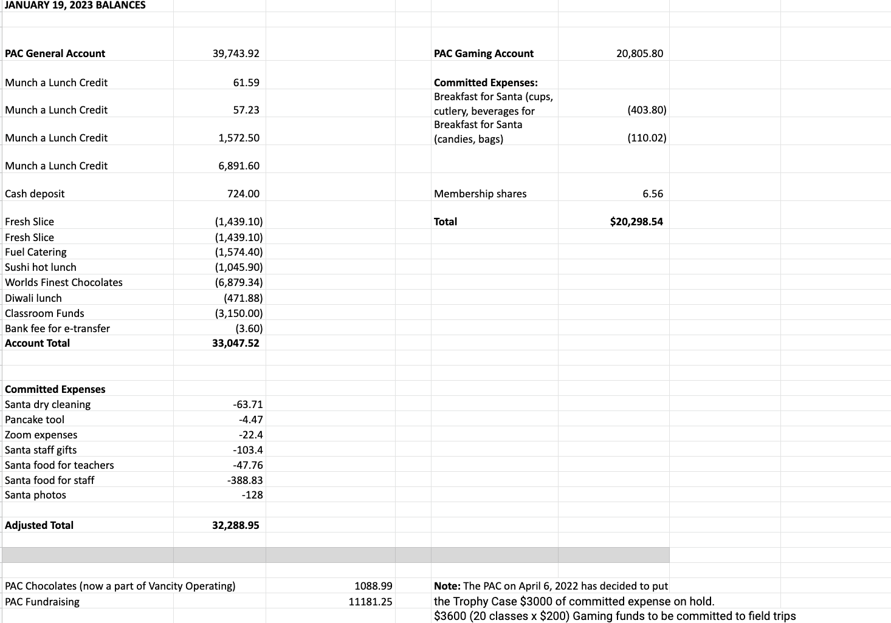

- Principal’s Report - (Ms. Laura Rhead)
Indigenous Land Acknowledgement:We are grateful to be working together on the traditional, ancestral, and unceded territories of the xʷməθkʷəy̓əm|Musqueam, Sḵwxwú7mesh|Squamish & səlilwətaɬ |Tsleil-Waututh Nations
Staffing updates:We welcomed back Ms. Amanda Dearlove in a full-time resource teacher role this month- Ms. Sy is on leave with her new baby! We also welcomed back Ms. Haley Cheng as classroom teacher toDiv. 11—she had been away for one year with her new baby and now is ‘mama’ and teacher. Thank you, Ms. Cheng and Ms. Dearlove!
We continue to advocate for support staff. We are currently without 1 SSA as there are no substitutes available in the district. Please speak with me if you would like more information or have particular concerns about any staffing. Thank you.
Keeping Safe: parking and drop off- please ensure you are walking students to school whenever possible; the staff parking lot is NOT available for parent use/drop off. Please do not park in the roundabout and have students wait in the car until the bell.
Please follow the rules of the road. Do not drop students off when you are in the middle of the road. Model great pedestrian tactics by following the lead of our school patrollers, using the crosswalk, and being aware of your surroundings. Let’s keep safe! Thank you.

Looking Back: thank you for our ‘Breakfast with Santa’ event! Your efforts and teamwork made for a very happy, special day for the students AND staff! Thank you for supporting the students throughout the first term- Mid-Year Reports are coming home in paper copy on January 31st.
Current Highlights!
- Basketball Club and Basketball Teams with practices and after school games! Thanks to our coaches, Mr. Kay, Mr. Biln, Ms. Gresham, Ms. Holly, Ms. Ho!
- Hot lunch Fridays! A HUGE thank you from the students for the efforts of all parent volunteers, and parents who are ordering
- Professional development themes… anti-racism teaching and learning; creating a ‘sense of BELONGING’ for all students, and community members.
- Student council and student leadership- social justice club, peer helpers, library monitors, lunch monitors, school patrol, assembly leaders, PAC babysitters- amazing kids!
…upcoming spirit days to know:
- Friday Jan 20 Anything But A Backpack (bring your stuff to school in anything that isn't the backpack you usually bring your stuff in! Kids are encouraged to be creative (but not disruptive to school). Kids giving some ideas/suggestions in announcements)
- Thursday Feb 16 Twins Day (Find a person to pair up with, or two people and be a trio, dress as "twins")
- Thursday March 9 Green Day (wear green)
- Friday April 14 Retro Day (a decades day idea -- kids working out details)
- Friday May 12 Cosplay Day (our updated take on Superhero Day!)
- Friday June 16 Beach Day (dress for the beach)
Coming Up:
- Black History Month
- grade 6 MDI
- student learning surveys (Feb-March)
- Pro D, Family Day (Feb. 17, 20)
- Pink Shirt Day Feb. 22
- African dance workshop week! Feb. 21-24
- Intermediate science celebration (details TBA)
- March 6-10: BOOK FAIR! **we would love to have parent/guardian help- please contact our teacher-librarian directly, Ms. Aujla: gaujla@vsb.bc.ca
Looking Ahead:
- Our school is currently FULL. If you have a child born in 2018, please enroll in kindergarten before Jan. 31 for priority registration. We will not be able to confirm placements until May when we are given our VSB staffing amounts. We hope to accommodate all catchment students, but this may not be possible. Priority is given to siblings wherever possible, as well. 42 catchment students are currently at other schools because we are full. There are 48 catchment students currently registered for kindergarten 2023!
- Grade 8 applications are due to the office asap. These will be collated and sent to various highschools in time for the application deadlines. We hope our grade 7s have a fantastic final term in elementary school!
- Lunar New Year assembly is set for 11am on Feb. 3. This is a school event, but we can accommodate a few spectators sitting at the back/standing. We know the students will enjoy bringing in the year of the Rabbit with our PAC volunteers and student leaders. Thank you!
Message from Div. 11:
Dear Sexsmith PAC, Thank you so much for organizing the Lunar New Year event for our school on Feb 3rd. We are so lucky to have such an amazing PAC! Division 11 has been working on a digital storybook based on the Zodiac Race story. We were wondering if there was any time in your event that we could play the short video of our book to be enjoyed by the school. So sorry for the late notice, it should only run for less than 5 minutes. If the event is all packed, no worries! We can find another way to share another time.
- PAC support and consideration for funding in various areas is so appreciated. We will prioritize and select school funds where necessary for these items in 2022-2023, but these items can also be for your consideration, in addition to the class discretionary funds, resource teacher funds and library/music funds:
  - New games and building toys for some primary classrooms, for lunch clubs facilitated by support staff (ie. Keva planks, chess, etc)
  - New book sets for intermediate students (novels in sets of 30- approx. $1900)
  - Playground equipment- new apparatus for the lower playground
  - More game lines and beautification along the primary wing outside corridor
  - Endless opportunities with tech and library and PE equipment- let us know what might be possible!
  - Grade 7 expenditures for 2023 is also a request from teachers- please let us know when we could discuss these. In the past, I’m told this was about $15/student. There are 64 grade 7s this year. Thank you!

- Please see my Sway newsletter from the week, as well asi our website, for all the updates, including a news story about Diwali at Sexsmith. https://sway.office.com/uIPlM1gAenkGjl7Y?ref=Link

- Hot Lunch Coordinators Report (Mike absent - presented by Mandeep)
Will keep these vendors for now
In the future, we maybe limit the vendors and possibly just use 2 vendors.

- Fundraiser Report (Lana)
- Last April we did a Purdy’s Chocolate Fundraiser, we did this previously around Easter.
- Other options for fundraising - Vandula Farms Fundraiser
  - Hanging basket / flower pot with spring flowers basket fundraiser before Mother’s Day. It is an easy fundraiser, they deliver plants to school, parents will pick up
  - Potentially flyers would go out at the end of March/start of April. Orders would be collected by April 27th and delivered by May 11th,
  - It is a more expensive fundraiser, around $30 per basket /pot
  - We will look into the Growing Smiles Fundraiser to compare prices.

- On-going fundraisers.
  - Fundscrip.
    - PAC Gift Card Fundraiser Gift cards are the perfect gift but can also be used to pay for things that you would have used cash for and you can help support your child’s school when you buy one!
    - Shop from the comfort of your home when you purchase gift cards through Fundscrip, and Sexsmith will receive a percentage of the gift card sale.
    - Choose from over 100 popular retailers like Toys R Us, Gap, Cineplex, Metropolis at Metrotown etc. Please use this link: https://www.fundscrip.com/Sign-Up.aspx?IID=2CBHHR
  - Oliver Labels
    - Keep your items out of the lost and found pile by labelling your personal items with Oliver's labels. Custom labels can be printed with your child's name to use on all their belongings. When you purchase labels from Oliver's Labels, 20% of the purchases will support Sexsmith PAC's fundraising efforts. Please use this link; http://www.oliverslabels.com/sexsmithelementary

- Other Business/Questions/Comments
- Breakfast with Santa (Lucia)
  - It was a big undertaking, Stan (a parent who previously ran the Breakfast with Santa helped) Stan and Lucia guided a big group of volunteers. Lucia will come back next year and help with transition.
  - 30-40 volunteers are needed on the on day of
  - Next time it would be helpful to divide the emails up for each day/type of volunteers
  - 5-10 people are needed the day prior to set up
  - 5 people are needed in kitchen
  - We were unable to keep every parent volunteer with their own kids class
  - Quantity was good, there was a little left over
  - We took notes for breakfast shopping list for next year
  - Lucia will make a checklist for all the jobs and food
  - One parent forgot to pay online, we took cash.
  - Some photos with Santa were water damaged
  - Maybe the parents can get digital

- Lunar New Year (Pandora)
  - February 3rd - Preparation for the lion dance is on-going, Practice is twice a week, they are doing very well. There are 20 kids involved.
  - Each kid will be given red envelopes containing candies and fortune cookies.
  - After the performance the staff will have a luncheon to the
  - We will need volunteers for setting up.

- Other fundraising ideas
- Asking for a donation from a big company, have a plaque named after them up or advertisement in Munch-a-Lunch.
- We can set up an account at Cobbs on Main Street, they give a % back to the school.
- Spring Fair Fundraiser, Mandeep has reached out to Gurmeet and Stan to find out details of how they previously ran the Spring Fair. It’s usually after school on a Friday in June, we decided on June 9th, 3-5pm. Grade 8 kids will help and volunteer too
.

Other Business
- March 29-30 - cyber safety speaker. Solos is a online safety program, it is expensive,there is a possibility of teaming up with another PAC to reduce the cost.

- The next PAC meeting is set for Thursday February 23rd at 6:15pm. The meeting will be held at the library.
- Future meetings scheduled on February 23rd, 2023, April 20th 2023.
- Meeting adjourned at 7:49pm

