SEXSMITH PAC MEETING May 18th, 2022• 6:25pm –7:pm in the library at Sexsmith
EXECUTIVE
Co-Chairperson: Mandeep Sidhu (absent) / Deljit Beesla
Treasurer: Novella Lui
Vice-Chairperson/Hot Lunch Coordinator: Mike Atwal (absent)
Secretary: Jacqui Crawford
Fundraiser: Lana Wong
Member at large: Eva Jung

GUEST
Principal: Ms. Laura Rhead

MEETING MINUTES
Deljit called the meeting to order at 6:25pm.

- Quorum was met – 13 members present

- Introduction and welcome statement and Indigenous Land Acknowledgement: We are grateful to be working together on the traditional, ancestral, and unceded territories of the xʷməθkʷəy̓əm|Musqueam, Sḵwxwú7mesh|Squamish & səlilwətaɬ |Tsleil-Waututh Nations
- Approval of agenda (no additions): Kam and seconded by Pandora.

- April 27, 2023, PAC Meeting Minutes - will be approved at the next meeting, June 22nd 2023.

- Principals Report
Indigenous Land Acknowledgement: We are grateful to be working together on the traditional, ancestral, and unceded territories of the xʷməθkʷəy̓əm|Musqueam, Sḵwxwú7mesh|Squamish & səlilwətaɬ |Tsleil-Waututh Nation
- Staffing & Calendar for 2023-2024:
- 18 divisions
- down in incremental staffing amounts (non-enrolling teachers) by 0.4362 FTE (2 days/week) due to headcount (complexity is not part of this budget item)
- Ms. Spiteri is consolidating at Shaughnessy so will not continue at SXS
- Ms. Wong, Ms. Sy on leave in the fall
- Mr. Thorn will be at another VSB school as we do not have openings and Ms. Marshall is returning to SXS
- Mrs. Hong is retiring from being a supervision aide this June
- Calendar 2023-2024- see attached for our proposed calendar
- School Fees for next year coming soon-
- $6 agenda
- $24 workbooks
- $35 school fees
- -no performance fee

Our May Newsletter has all the updates!
Here’s my latest video link with updates and reminders: https://youtu.be/n5yI_-hVz38
____________________________________________________
Have you seen our latest Sexsmith Elementary NEWSLETTER? Check it out here: https://sway.office.com/g9u74tAYyYrejKZH?ref=Link

Please help us know your thoughts about Student and Family 'Sense of Belonging' at Sexsmith: https://forms.office.com/r/hh8d96YjRc
Thank you, to all our parents/guardians involved with the Filipino Festival, sports day, the spring fair, grade 7 farewell and all the fun in these next few weeks!
Sincerely, Laura Rhead: lrhead@vsb.bc.ca
The Staff and Students of J.W. Sexsmith Elementary School Invite You to our Volunteer Appreciation Tea in the Library on Wednesday, June 14th 2pm. If you have volunteered with field trips, PAC events, driving, or in other ways, we invite you to join us in recognition of your generous help and support!

- Treasurer’s update - Novella

- Currently our operating account balance is $52 854.69 Some expenses with the PAC meeting, babysitting and refreshments, hot lunch expenses, we ordered some checks, we had 2 e transfers and 5 transactions for hot lunch. We received 3 credits from Munch-a-lunch including the family photo fundraiser. The closing balance came to $48 746.84.
- We have sent a check to Churchill, $500 for the scholarship.
- We have committed to $13 600 for the technology fund.
- We have a hot lunch expense of $189.37
- $35.49 for the volunteer’s refreshments for sports day.
- $135.32 for food at tonight's PAC meeting.
- Staff appreciation treats at $154.40
- Lump sum reimbursement of $84.40 for our BC Society application / postage and our monthly newsletters $383.87.
- We have an adjusted balance of $33 748.39

GAMING ACCOUNT
- We have an opening balance of $15 865.64
- We had a check order of $94.95
- Current closing balance is $15 770.69
- The check was passed to Laura for the display case and bulletin board earlier this year $1983
- Check given for sports day fruit that Pandora purchased this week for $272.85

- Membership shares of $6.88 in the Van City Account

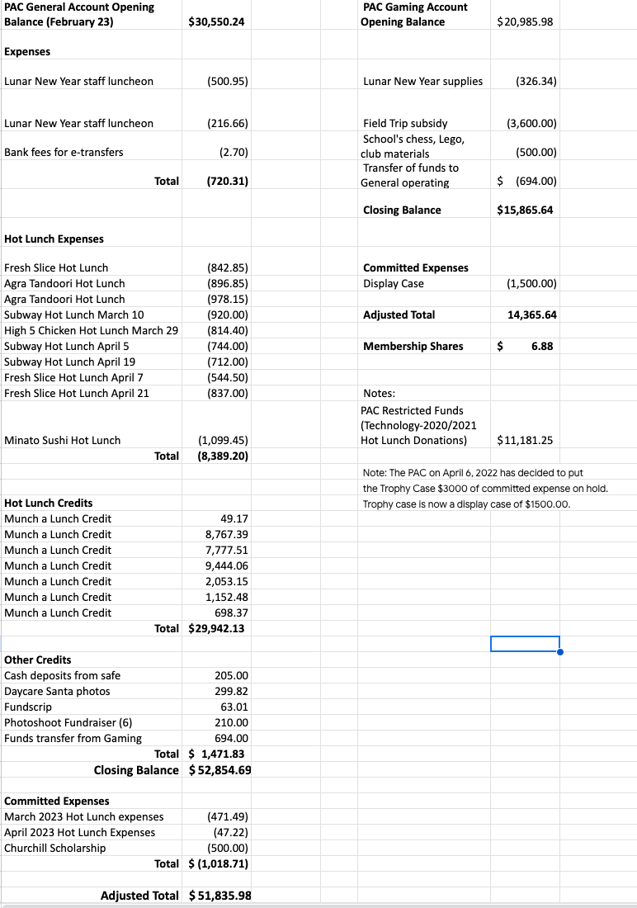

- Hot Lunch Coordinators Report (Mike absent present by Deljit)
- We are planning to set up a hot lunch survey, Novella contacted D-pac and they shared a survey used previously. Novella will work with our PAC executive to adapt the survey to make our own. If you want certain items or have suggestions to be added to the survey, contact the PAC.
- We will send it out in June.

- Fundraiser Report (Lana)
- Photo Day - organized by Pandora. We had 18 slots and they sold out on the first day. It was $35 a time slot, minus bank fees and munch-a-lunch fees, profits raised $615.48. We get a percentage of any packages ordered. It was a good fundraiser and we will run it again, maybe in November in time for Christmas. Next time we will add cell phone numbers to the sign up sheet.

- Lana contacted the chocolate almond fundraiser vendor (World’s Finest Chocolates) and the prices did not go up from last year. Pre-order by June 15th. Order 10% more than last year, as we sold out last year. so we will order 250 boxes.

- Fun Fair discussion
  - Go to Surrey - party games - they are unavailable to deliver so Lana and Lucia will go and pick it up
  - Presale of tickets - 10 in a bundle - in a punch card $1 a ticket, through Munch-a-Lunch
  - Juice boxes and snacks (popcorn, freezies and chips)
  - Email will be sent out to parents early next week through Laura
  - Deljit will set up Munch-a-lunch
  - Janelle will set up a volunteer coordination and sign up online
  - Reach out to Churchill students (previously at Sexsmith) to help out.

- Sports day (tomorrow)
  - Pandora bought all the fruit, it's in fridges at the school. Tomorrow morning will be busy, not much time for meet and greet for volunteers, we will be relying on our senior volunteers to make people feel welcome. Laura suggested using the staff room for organising fruit. Volunteers will drop off fruit trays to Winona. Hot Lunch is pizza. Freezies at end of the day

- On-going fundraisers.
Fundscrip.
    - PAC Gift Card Fundraiser Gift cards are the perfect gift but can also be used to pay for things that you would have used cash for and you can help support your child’s school when you buy one!
    - Shop from the comfort of your home when you purchase gift cards through Fundscrip, and Sexsmith will receive a percentage of the gift card sale.
    - Choose from over 100 popular retailers like Toys R Us, Gap, Cineplex, Metropolis at Metrotown etc. Please use this link: https://www.fundscrip.com/Sign-Up.aspx?IID=2CBHHR
Oliver Labels
    - Keep your items out of the lost and found pile by labelling your personal items with Oliver's labels. Custom labels can be printed with your child's name to use on all their belongings. When you purchase labels from Oliver's Labels, 20% of the purchases will support Sexsmith PAC's fundraising efforts. Please use this link; http://www.oliverslabels.com/sexsmithelementary

- PAC has set up an account with Return-It Express.
  - Visit any Return-It-Express location. Find a location here.
  - Bring your rinsed refundable containers in a sealed, clear plastic bag.
  - Enter the account number 604-713-4901 (school’s phone number) into the Express kiosk and print out the number of labels you need.
  - Tag each bag with a label and drop the bags off in the designated Express drop-off area.
  - Funds collected will be credited directly to the Sexsmith PAC account to benefit the school.

- BUY BREAD, EAT FRESH, GIVE BACK!
The Sexsmith Parent Advisory Committee has partnered with COBS BREAD at 2924 Main St.
- Effective January 27, 2023, all items purchased by members of the Sexsmith community will raise money for our school PAC!
- When you are at COBS, before you pay for your baked goods, let them know you are a part of the Sexsmith school fundraiser and 5% will be donated back to our school PAC.

- New business
- May 30th - Welcome to Kindergarten event. A volunteer from the PAC will be present to help recruit more parents/guardians to volunteer with the Pac, the event is from 10:30 to 11:45.

- The next PAC is the Annual General Meeting, set for Thursday June 22nd at 6:30pm. The meeting will be held at the library.
- Meeting adjourned at 7:20pm

