Change in the Safe Arrival Line
Please be advised that there will be a change in our safe arrival line starting January 26. When calling in we now need to use our school code which is 99.
Options are:
- Call our safe arrival line 604-713-5403, press 1 and enter the code 99
- An alternative # is to call 604-713-5159 and hit code 99.

When calling in you will be reminded with the following school prompt – “For safe arrival, press 1, Enter 99# for the two-digit extension when prompted.”

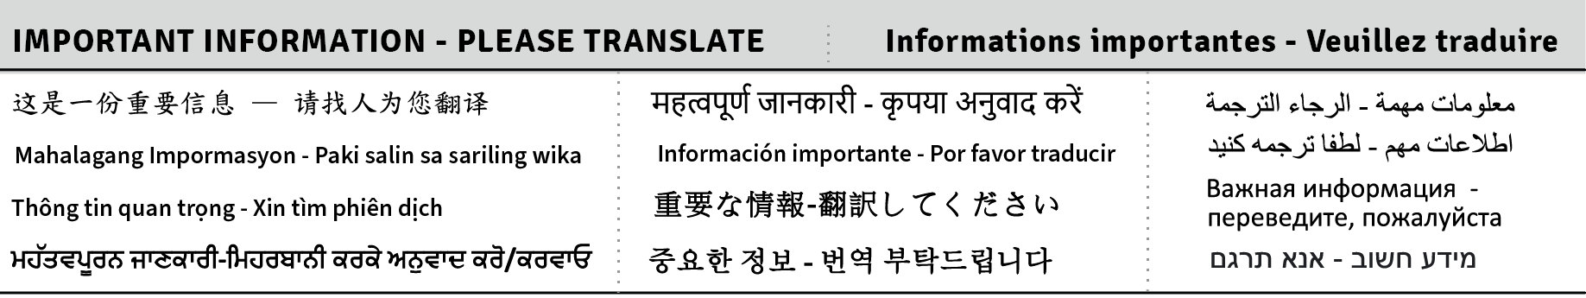
Dear VSB community,
We are planning the budget for the next school year. We want to hear from you so our budget reflects what matters most for student success.
Most of the funding provided to VSB goes to staffing based on collective agreements and legislation and to operating and maintaining schools. Your input will help trustees decide how to invest available dollars for student success.
Please take a few minutes to complete our short survey by Feb. 1, 2026.
Learn more: vsb.bc.ca/budget
Take the survey
Thank you for helping us build a financial plan that supports every learner.

School Sports – Basketball – We are running the following basketball teams this year. Senior Girls – Gr. 5 – 7, Junior Boys Gr. 5 & 6 and Senior Boys Gr. 7. Practices have already started and permission slips will be going home this week. If your child has not signed up or attended practices already, please get them to see Mr. Patrick for more details.

After school programs – We have lots of after school programs starting in January – Lights Up, Pedalheads soccer and Young Rembrants. Make sure you check out the links on our website https://www.vsb.bc.ca › general-gordon under after school programs to sign up if you haven’t done so already.

Regards,
Stephen Leung, Principal & Pawan Sumra, Vice Principal

