**General Gordon Elementary School**

**2268 Bayswater Street Vancouver, BC**

**V6K 4P5 604-713-5403**

Proud to be Wolves



We R.I.S.E. to success through their Relationships & Belonging, Intellect, Spirit, and Emotional Wellbeing.

Message from the Principal

I’m happy to welcome all of our families to Gordon for the new school year. I’m sure you will find our school a supportive learning environment. Our circle of care, motto, and mission statement put children, character, and learning at the forefront. We want our school to be a place where students feel safe and valued, and where they are encouraged to do and be their best.

This booklet contains some of our Gordon policies and procedures. It is not exhaustive, so if you have any further questions, our office staff would love to help you.

**General Gordon Mission Statement**

Gordon Elementary School is a vibrant and active community of staff, students and families. We strive to provide opportunities for students to develop intellectually, emotionally, physically and socially while doing meaningful work in a safe and socially responsible environment where self-evaluation is encouraged.

**Safety and Security Policies and Procedures**

# Volunteers

Our school is enriched by the many parents and community members who volunteer. The Board of Education Policy requires that all volunteers in schools complete a Volunteer Conduct Agreement. If you anticipate that you may be volunteering during the school year to work with students other than your own, please go to the school office for a form and return the completed form to the office. If you are working with groups of students without a VSB staff present we will also request a criminal record check. The completed forms will be kept in a confidential file. Those who drive students, are required to complete a 3rd party liability form, present their driver’s license, and prove they have at least 1 Million dollars in insurance. When volunteering at the school, we request that you sign in at the office as you arrive and put on a visitor’s badge.

# Visitors

All visitors are expected to report to the office upon entering the school. This is a safety and security measure, it is important for us to know who is in the school should an emergency arise. Visitors are expected to sign in at the office and collect a visitor badge, which must be displayed while in the building or on school grounds.

# Student Absences and Late Arrivals

For the safety of all students, all students will be placed on the safe arrival system this year. Please call the school and press option 1 if your child will be late or absent. Please leave a message on the answering machine. It operates 24 hours a day. Students who arrive late to school, after 9:05 am must report to the office and sign in. Any students unaccounted for after this time may result in a phone call or email home to verify their absences on that day. Please ensure that the school has updated phone numbers and the order you wish to be contacted. Please make sure when you provide a phone number that you are able to answer the phone when we call you.

If you or a designated adult needs to pick up your child from school during school hours, please sign them out at the office. If you return the same day, please sign in at the office before proceeding to the classroom.

If you planning to go on vacation, please fill out an Extended Vacation or Move form and submit it to the office. Please note the maximum number of days your child may be away is 30 school days. Absences that exceed this amount may result in the child being withdrawn from the school. If we have a current waitlist for this grade level your spot will be offered to the other child on the waitlist.

When returning you will have to reapply at the school and depending on space your child may be placed on our waitlist.

We do not encourage long absences or vacations. Children who miss many days of school become behind in their studies. It is difficult for them to make up the missed lessons and it is not the teacher’s responsibility to re teach these lessons. Areas missed while on extended vacations falls on the parent’s responsibility to ensure that this curriculum is taught and the child continues at their grade level.

Teachers are also not responsible to provide missing work or work to be done while away. If you choose to take your child on an extended vacation the assumption is that you will keep them up to date on all curriculum missed during their absences.

# When Children Are Ill

In fairness to all, please do not send your child to school if in the morning there are definite signs of sickness. Students who become ill during the day should go directly to their teacher. Our policy is to get students who are ill home as soon as possible. Our practice is to call parents and ask that the students get either picked up or other arrangements made. For this reason, it is important that parents keep up-to-date work and emergency phone number information at the office.

# Medical Alerts and Requests for Administration of Medication

A Medical Intervention Form must be completed if your child has an existing medical condition that we at the school should be clearly aware of and have documented. A Request for Administration of Medication Form must also be completed if your child will be taking any form of prescribed medication at the school. Please note that students may not be in possession of any medication at school unless specifically authorized by the principal, and staff may not administer medication to students unless the required form has been completed and signed by a parent. No over-the-counter drugs such as Tylenol or Aspirin can be supplied by the school.

# First Aid Procedures

The School Act gives teachers the same responsibility as that of prudent parents. “Prudent practice” varies from parent to parent, but we would rather err on the side of caution. When, in our judgment, an injury or an illness is something more than minor or casual, we contact the parent. If we are unable to reach a parent, we try the emergency number you have given the school. If we are unsuccessful in contacting you or your Emergency Contacts, we take the necessary actions to ensure your child is cared for. In obvious emergency situations, we will call 911 and request an ambulance. Please note there is no nurse or doctor on site to deliver first aid.

**Are you returning late or leaving early for a school holiday?**

Any student who returns several days late from vacation will be required to fill out a Late Return form which is available for the office. Students who arrive later than the start date for school start up, Winter Break, Spring Break or any other extended break will be required to fill out this form.

Students who do not fill out this form risk losing their place at this school. As we are often running waitlists throughout the school year, students who have not notified the school within the predetermined acceptable return time may be withdrawn in favour of students on our waitlist.

If you are leaving prior to the end of school, you must also advise the school. Please email our safe arrival [gg-safearrival@vsb.bc.ca](mailto:gg-safearrival@vsb.bc.ca) indicating what dates your child will be away and the reason for this early departure. Please, out of courtesy also advise your teachers.

Please note students who choose to depart early will not be given make up work by the teacher’s as this as the parents choice to depart early.

# Emergency Procedures

**Fire Drills & Other Emergency Situations** Fire and earthquake drills are held to teach children how to vacate the school quickly, quietly and in an orderly fashion. Proper behaviour and a serious attitude are demanded from all students during these drills. If you enter the building during a drill, please exit the school and proceed to the gravel field. In the event of an actual emergency, please ensure you have alerted staff and followed established process before taking your child off school property.

**Sports Teams/Clubs/After School Programs** Please watch for notices offering opportunities throughout the school year.

# Emergency Closures

On the rare occasion, school may be canceled due to extreme winter weather conditions. The decision to close a school can only be made by the superintendent of schools. To get information about emergency closures, please go to the district website [www.vsb.bc.ca](http://www.vsb.bc.ca/) or listen to the radio stations listed below, as school staff may not be able to answer the school phone lines. Announcements on these stations will be made between 6:00 and 8:30 AM.

*CKNW 980 AM CKWX 1130 AM CBC 690 AM JACK FM 96.9 AM*

# Before and After School Supervision

We have staff supervising 20 minutes before and after school. Please note that there is no supervision outside of these times and students cannot be left unsupervised after this time. All students should be picked up or on their way home by 3:20.

**Leaving School Grounds at Recess & Lunch** For their own safety, students may not leave the school grounds during the school day without written permission from their parents. Students who routinely go out or home for lunch must have written permission that is provided at the start of the year and indicates the duration of this privilege. The student must also sign out and sign in daily in the Student Sign-out Book.

# Arriving Late or Leaving Early

# Any students who arrive after 9:05am will be required to come to the office to sign in. The students should then proceed directly to their classrooms. This step is important to allow the office to update potential absences in the system and avoid calling you for the safe arrival program. Any students who are leaving early for any reason MUST also sign out of the office. We ask that parents come into the office and sign their children out personally.

# Wheels Up – 20 minutes before and after school

# We encourage the use of wheeled vehicles at our school, but for 20 minutes before the first bell and 20 minutes after the last bell we ask that you walk your bikes to and from the sidewalks before riding. This will eliminate the chances of collisions with other pedestrians during our most busy times. After this time please be mindful as there are still many students playing outside and you may want to find a better open space to ride your bikes.

# School Streets Program

# Through a program with the City of Vancouver there may be days and times that street outside the main school entrance on Bayview Street may be closed to vehicular traffic. We encourage families to participate in these activities as they foster school community and physical activity.

# 

# Hot Lunch Programs

Parents have an opportunity to participate in a paid lunch program on Mondays and Thursdays. Pizza will be available on Wednesday’s. Please refer to the website for more information on how to log in via Munchalunch.

# Animals on School Premises

For the safety and comfort of all, we ask that pets be kept off school grounds. Please do not bring your pet into the building unless you have permission from the principal.

# Cell Phones

We recognize that cell phones are an important communication tool for parents and students. Students may bring their phones to school, but to avoid distraction during school hours, students are expected to keep their electronics out of sight from 9am to 3pm. Some teachers will collect all cell phones at the start of the school day and some may request students to use their devices for educational purposes. If students are using their phones inappropriately, they will be confiscated and will remain with the principal for the day. If they are confiscated a second time, parents will be called to pick them up. Students are welcome to come to the school office to use the cell phone to call you directly.

# Internet Use

Gordon is very fortunate to have several iPads, laptops and desktop computers that students use to access the internet. In addition, some students bring various electronic devices to school. We expect students to follow their respective teacher’s rules regarding use. Our school policy for student use of the internet is consistent with the district policy as outlined in the Acceptable Use Policy contract that we request parents to review. Even if you have already completed this previously, we ask that your take the time to review, sign and return this contract on line if you would like to make changes. The internet is used to support classroom learning, and students may access the internet only when directly supervised by a teacher. Students who fail to comply with these expectations will lose their user privileges and/or face disciplinary action. Classroom teachers will also review these policies and the agreement with students in September.

**New Online Forms**

To reduce the amount of paperwork printed and returned to the office we are now putting many forms online. The walking field trip form, media consent forms and other forms can be found at <https://myforms.vsb.bc.ca/> please review these forms as they are important forms that once filled out are active for the entire school year.

**Neighbourhood Walks**

We are lucky to be located in an area that has many parks and beaches. Many teachers like to take their children on neighbourhood walks throughout the school year. Once the neighbourhood walk form is filled out this will allow the teachers to walk at any time with your children in our area. If your child does not have this important form filled out they will not be able to accompany the rest of the class on these walks. Any students not able to participate or haven’t completed their forms will remain at the school either in the office or with an alternative teacher until their classes return from the walk.

**Field Trips**

To enhance school learning teachers may opt to plan field trips throughout the school year. Costs will vary depending on the location and type of field trip planned. We ask parents to pay for these amounts online through <https://vsb.schoolcashonline.com> Please be advised that if your family is unable to pay for any reason, you may contact the office and we may be able to waive these charges. The Vancouver School District has a policy that all children can attend field trips regardless of their families’ financial needs.

In order to attend all field trips, students must return their signed field trip notices in a timely fashion. If the activity has a certain level of risk, phone calls home for permission will not be adequate.

# Student Use of the Telephone

Students are permitted to use the office telephone with permission from their classroom teacher or they have permission granted by other staff. Use of the phone should be restricted to emergency or urgent calls only and not to arrange play dates.

# Communication

It is important to establish good two-way communication between home and school. The teaching staff is encouraged to contact parents about exciting accomplishments or concerns they may have about a student. Communication may be done through agendas, email, notes or phone calls.

If you have a concern, it is important to discuss it first with your child's teacher. It is the teacher's responsibility to keep the principal informed. If parent and teacher concerns are not resolved, the principal will be consulted and involved. The priority for all of us, is what best meets a student's needs. You can be assured that all matters will be treated confidentially and that we will make every effort to rectify situations that are found to be unsatisfactory for our students.

# Professional Development Days

Under the School Act, school staff are provided five days in the school year for professional development and two days for curriculum implementation. These are days that have been allocated in addition to the regular instructional and administration days. Students will not attend on these days. Please refer to the school calendar for specific dates.

**Website:** [http://go.vsb.bc.ca/schools/gordon.](http://go.vsb.bc.ca/schools/gordon) This site contains all the up to date school events, announcements, information and other documents you may need.

# Parent Advisory Council

Gordon has an active Parent Advisory Council that meets regularly. Those involved in the PAC find that it provides a meaningful opportunity for involvement in the education of their child and in the life of the school. Parents are actively encouraged to participate in fundraising, workshops, social and school-wide events such as our Spring Fling. Scheduled meetings are noted in the school newsletter. Everyone is welcome! Please take the time to visit their website for up-to-date information and events https://gordonpac.ca/

# Library Policies and Routines

Students sign out their books during their weekly library periods or other times when the librarian is present. Books should be returned weekly. Borrowing privileges will be temporarily restricted when overdue items are not returned. For lost and damaged material, the librarian will assess a amount payable.

**Student Responsibilities - Code of Conduct** It is expected that students uphold a high standard of behaviour when at school, on the way to and from school, and while attending school functions or field trips. Students are also expected to demonstrate high standards of work habits, arriving at school and class on time, being prepared with the necessary supplies and materials, and completing all in-school and homework assignments.

# Reporting

There are three formal written reports sent home at the end of each term. Conferences take place in Term 1 and 2. On these days students are dismissed at 2 PM. If concerns arise throughout the school year, you are welcome to contact your child’s teacher to arrange extra meetings if required.



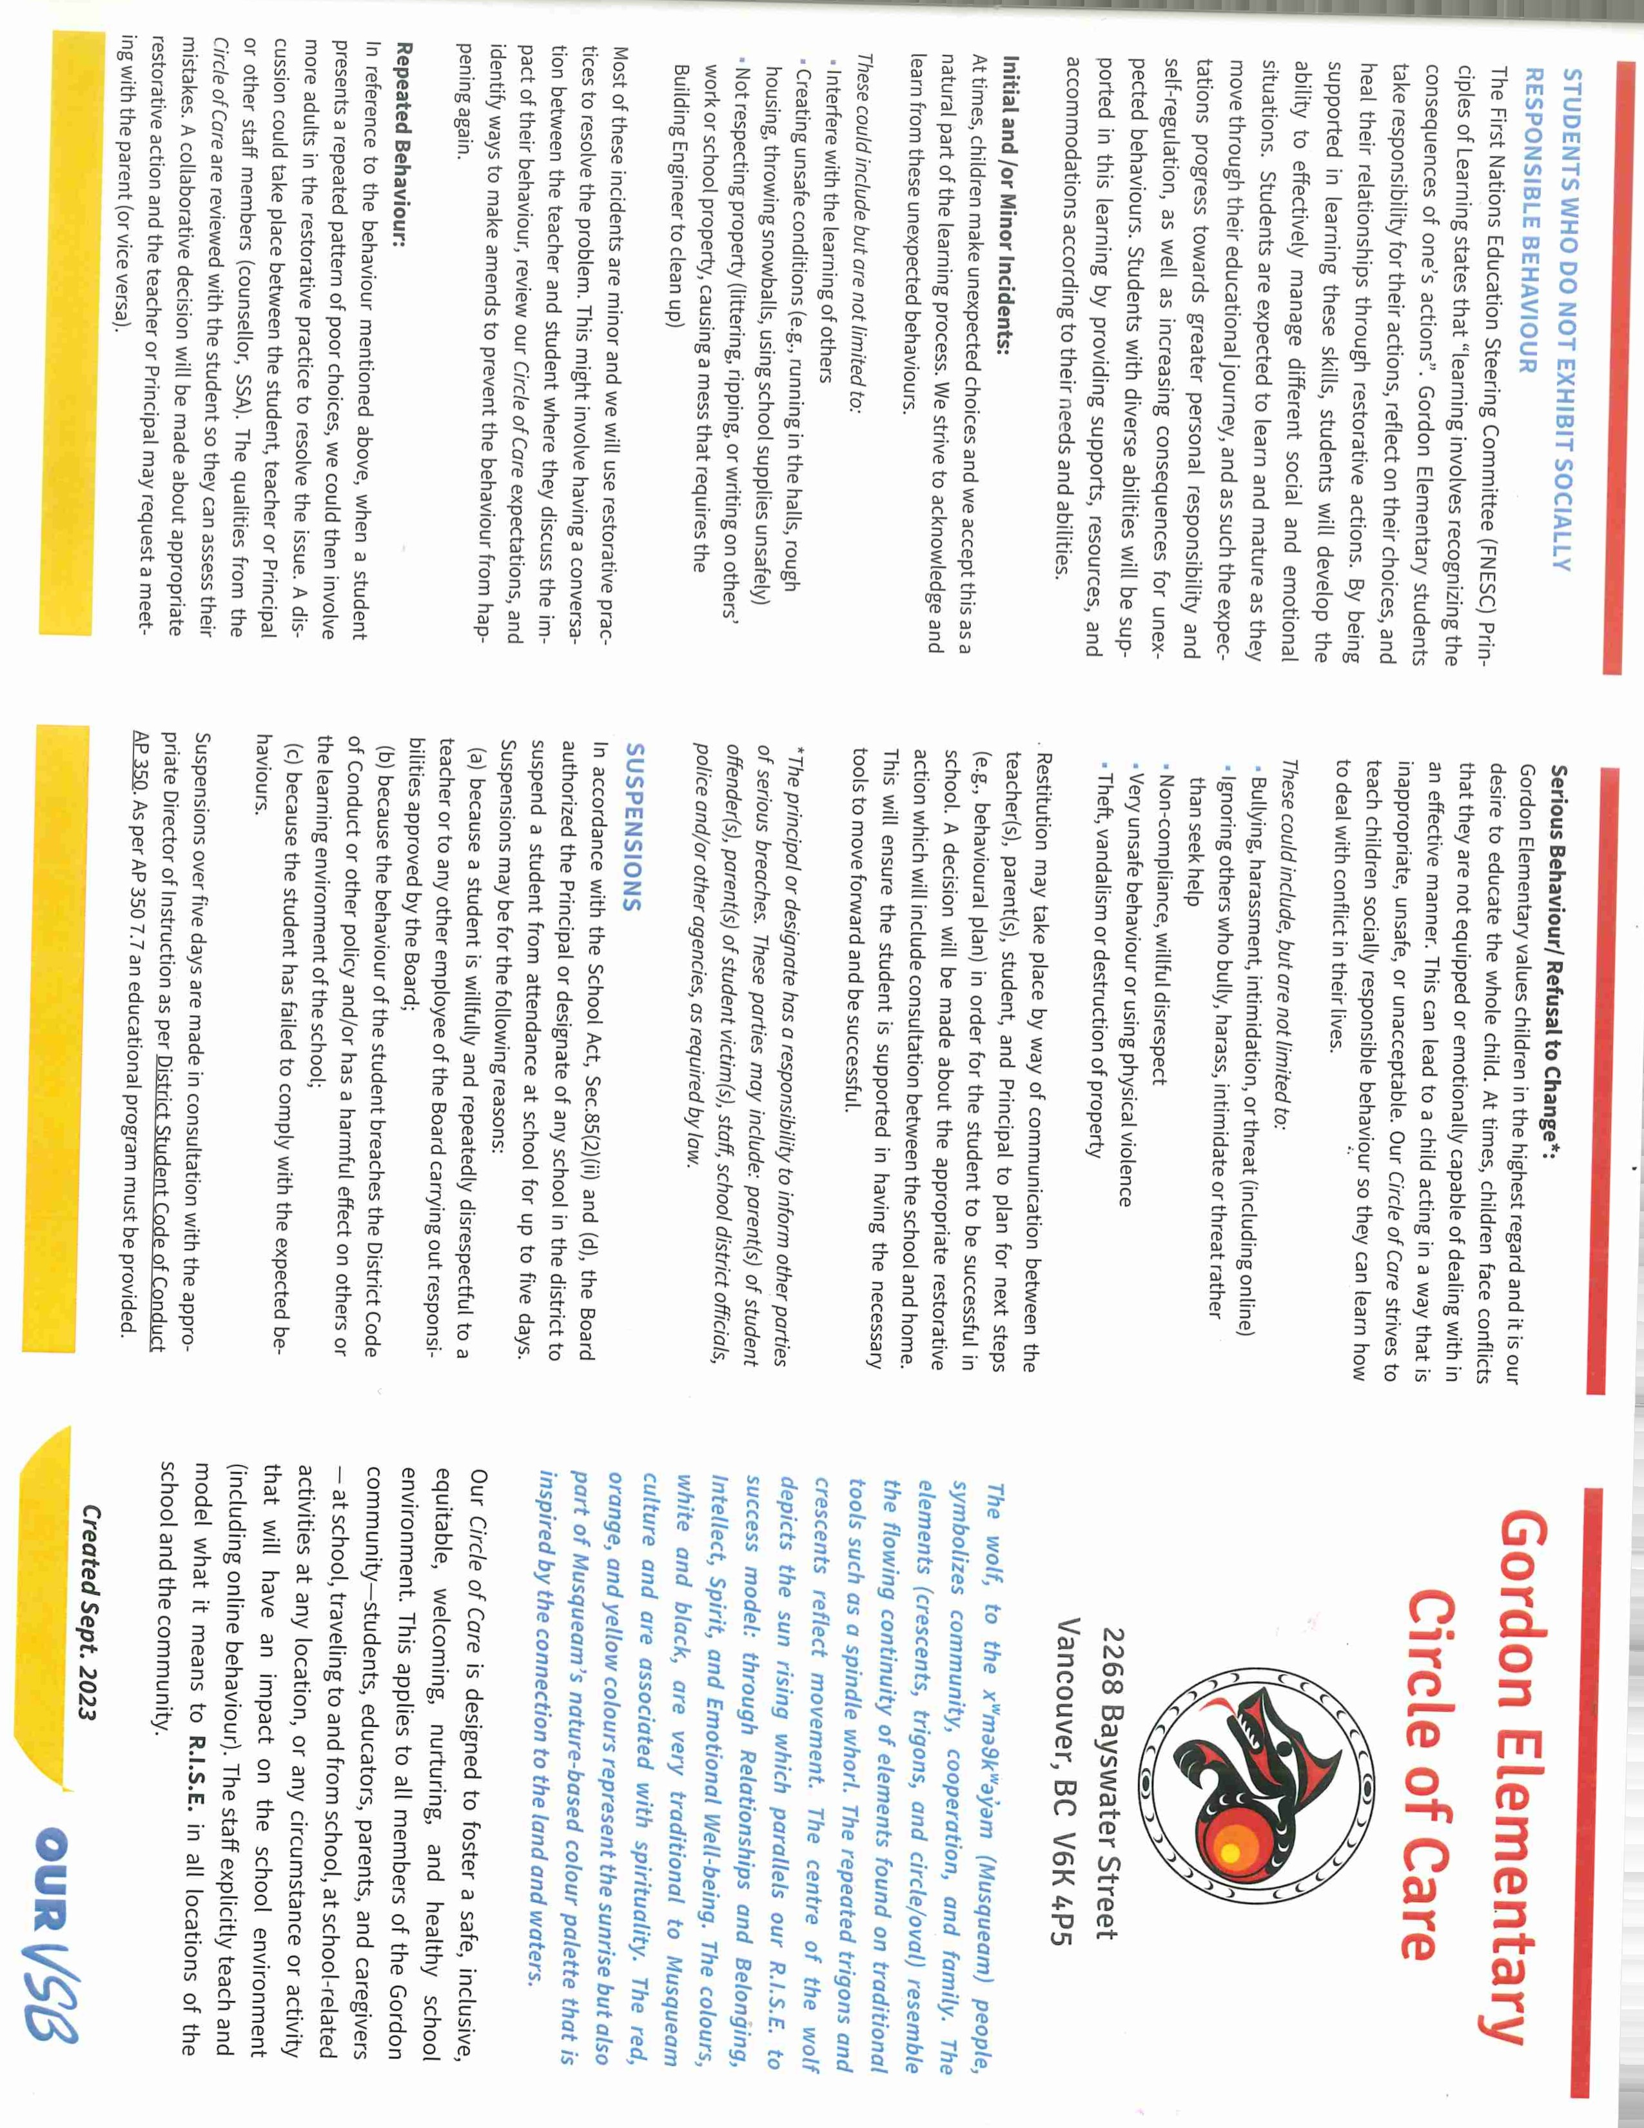

**General Gordon Daily Schedule**

**Bell Schedule** 8:55 am Warning Bell 9:00 am Classes Begin 10:30 am Recess Begins 10:50 am End of Recess 11:35 am Lunch Begins 12:15 pm Outside Play 12:57 pm End of Lunch

2:58 pm End of School Day 3:20 pm End of After School

Supervision

**School is in session Monday to Friday from:**

**9:00 AM to 2:58 PM**