Magee Theatre Fundraising
Seat Sponsorship Order Form
Add your name to the legacy of Magee by purchasing a name plate in our amazing theatre
Commemorative Nameplate – Actual Size
2 1/2 X 7/8 inches (6.35 X 2.23 cm)
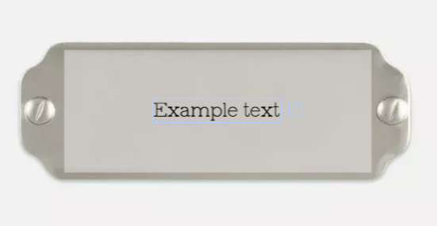
Indicate the message or name you wish to see on the nameplate
Suggestions:
Family Name – Year Grad Name – Year
Favourite Teacher In Memory Of
Grad Class In Honour Of Corporate Recognition In Appreciation
________________________________________
________________________________________
________________________________________


NUMBER OF SEATS _____ x $1000 each = $__________ TOTAL
□ Cash (in person only)
□ Cheque (payable to “Magee Secondary School”)
□ Credit Card through this link
Donated by:
Name: _____________________________________________
Address: _________________________________________________
Province: _________________________ Telephone: __________________________________
Postal Code: ________________________
Note:
» Seats will be designated on a first come, first served basis. There are 160 available
» One nameplate per seat – No limit to number purchased

