

**LORD STRATHCONA ELEMENTARY**

592 East Pender Street

Vancouver, B.C. V6A 1V5

Tel: 604-713-4630 Fax: 604-713-4633

Principal: Mr. Jason Eng Vice Principal: Ms. Janine Lamb

PAC Chairperson: Mr. David Chen

**APRIL NEWSLETTER**

Dear Strathcona Families,

It is hard to believe there are only two months of school left before summer holidays. The energy at Strathcona is high, and the school is bustling with activity in classrooms, the gym, library, auditorium, and music rooms! We are all looking forward to the Spring Concert taking place on April 25th and 26th. Thank-you to Mr. Butler and Mr. Mitchell for all their work leading and instructing students, and coordinating concerts. The music program at Strathcona is thriving! May and June provide many opportunities for community get-togethers, and I look forward to connecting with you at upcoming events, including Sports Day on May 17th and the PAC hosted Spring Fair on May 31st. We are so grateful for PAC working together to put together this fun event, along with their ongoing support of field studies, the Strathcona Dance Program, Gr 6/7 Outdoor Education, and intermediate STEM (Science/Technology/Engineering/Math) project resources.

In recent months, a group of staff have met to discuss recess and lunch at post-seismic Strathcona. Our goal is to create a recess and lunch environment where students have engaging, productive activities to do during both outside and rainy indoor days. It is important for students to get fresh air, exercise, and socialize with one another. To date, students have really enjoyed using PE equipment at recess and lunch. In recent weeks, we have introduced a number of rainy day centers in the bottom floor hallway to keep primary students busy during inclement weather. These activities have been a big hit! This past week, we also had a school assembly to reintroduce the Solution Room at Strathcona. This is an avenue for students to connect with a staff member in order to effectively and cooperatively solve problems when difficulties arise at recess and lunch. Hopefully the recess and lunch environment at Strathcona will continue to flourish with these adjustments, in addition to preexisting gym, library, and lunch programs.

Happy spring everyone!

Sincerely,

Jason Eng

Principal

**MS. HONG’S LIBRARY CORNER**What an exciting year in the library! We kicked off the school year with our first year of the Chapters Indigo Love of Reading Grant. Then, we made the big move from our old space by the gym, to our new, beautiful library. If you haven't seen the new library yet, stop by for a peek! We've had fun library events, including Harry Potter Week and Minecraft Reads Week. We'll wrap with Star Wars Reads Day on May the Fourth. The final due date for all students books is JUNE 6. So far this school year, 13,598 books have been borrowed. Division 12 has the most number of books borrowed with 1,401 borrows!

**SCHOOL ORGANIZATION FOR 2018-2019**

We are in the process of establishing our enrolment projections for the 2018 – 2019 school year. If you know that your child will not be returning to Strathcona in September 2018, please call our office at 604-713-4630 to notify us.

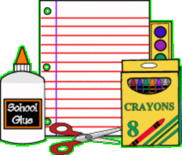**2018-19 GENERAL SCHOOL FEES**

The 2017-18 School Fees notice sent home in May of last year stated that this school year would be the final year that school supplies would be purchased for a set fee by the school district and that starting in September 2018, parents would need to purchase items on their own.

**Please note that the general school supplies fee will still be charged for the upcoming 2018-19 school year.**

The Vancouver School Board will continue its service of purchasing basic school supplies in bulk at wholesale prices and passing the cost savings on to families. The School Supply Fee for 2018-2019 will remain at $25.00 per student. This fee covers basic consumable school supplies used for students’ personal use such as paper, writing tools, glue sticks, erasers, exercise books and art supplies. Supplies are provided for the full year.

**DAILY ATTENDANCE**

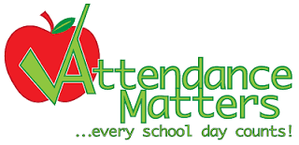Daily school attendance is important for all students. Students who attend school regularly are more engaged in learning, have a greater sense of belonging to the community and are more likely to graduate high school. Perfect attendance should be a goal because even missing two days of school a month works out to a student missing the equivalent of one month of school a year. We are concerned that irregular attendance will continue to be an issue. Research shows that 18 school days missed can lead to one grade lost. Your child should attend school every day unless there is an unavoidable cause, for example, illness.

When children arrive at school on time they start the day off more positively. With regular school attendance students are able to build stronger relationships with their teachers and classmates. It is difficult to ‘catch children up’ when they miss a significant amount of teacher instruction because of late arrivals.

**VANCOUVER BOARD OF EDUCATION GIFTED/CHALLENGE SUMMER PROGRAM** *Where Thinking Comes to Mind -* Gifted/Challenge Summer Program July 9 – July 27, 2018.

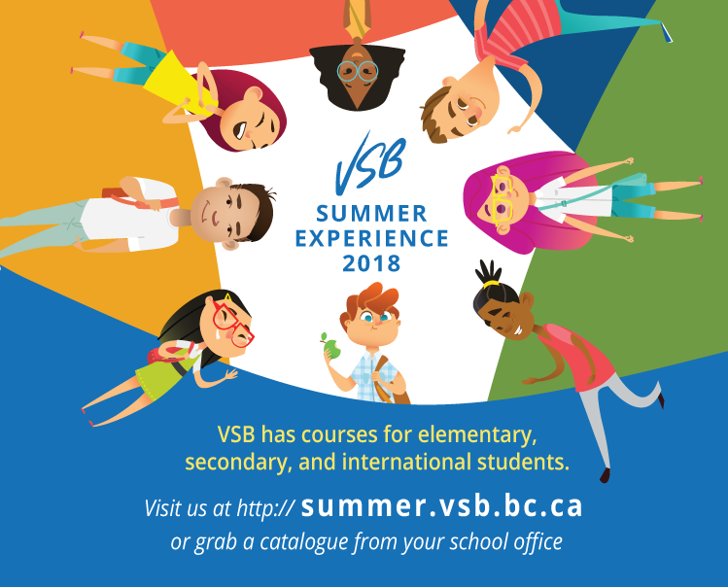This summer the Vancouver Board of Education will again be offering the Gifted/Challenge Summer Program at Mackenzie Elementary School (960 E. 39th Avenue). Families will be able to apply to participate in both morning and afternoon sessions each with courses approximately 3 hours in duration. Classes are available for students who have completed Kindergarten through Grade 7.

The courses are not only designed for students who have been designated as gifted but also for those who have strengths in particular subject areas such as Math, Science, Writing or the Arts. This also includes students who, for example, may have difficulty with written output but excel in hands-on or creative activities such as aviation experiments, LEGO robotics, computer programming, movie production, or art. Because of this, the program offers a wide variety of subject areas and styles of courses to meet these varying needs.

The application process opens on Thursday, March 1, 2018. Applicants will be asked to complete an online application form and submit a copy of the student’s most recent report card in PDF format.

For further information and the link to the registration form please visit the Gifted/Challenge Program website at www.vsb.bc.ca/glsp.



**GRADE 7 GRADUATION CEREMONY**

To all parents or guardians of Grade 7 students, there will be a graduation ceremony on June 22, 2018 in the gym at 11 AM. Mark your calendars for this exciting moment!



**ART EXHIBITION**  
Division 2 is hosting our final 2 exhibitions in the coming months before school ends. An exhibition about Scent and Taste will be held on Thursday, May 3 at 5:30 PM, and the final exhibition for a Contemporary Art Gallery wrap up on Thursday, June 14. Harrell Fletcher will be in attendance as well. Everyone is welcome to attend!

**STRATHCONA SMILE MAKERS**

**Presented to the Grade 4 students at Lord Strathcona Elementary School by: Vancouver Community College 3rd Year Dental Hygiene Students Alissa, Jenn, Mildred, & Tamara

***Day 1: Cariology, Brushing & Flossing***

Students learned about the different factors which contribute to the formation of cavities, particularly addressing acidic fruit juices and sugary foods or sodas. Proper brushing and flossing methods were also shown and taught by the VCC students, and a brushing chart was provided, in an effort to encourage the Grade 4 students to develop healthy oral hygiene habits.

***Day 2: Tobacco Prevention and Nutrition***

Students were educated on the negative effects of the chemicals found in cigarettes. The students also watched a live demonstration displaying healthy vs. tar-filled pig lungs, learning how tobacco affects breathing ability. The students then decorated a personal pledge to say “No” to smoking, and brainstormed 5 reasons why. Nutrition labels were also discussed, analyzing the sugar content of commonly consumed foods/drinks.

***Day 3: “Faux” Dental Hygiene Clinic***

During the final day of the oral health program, the students transitioned between several stations to learn about taking dental impressions, x-rays, and the tools dental hygienists use to keep teeth clean and healthy. A dental chair was presented, and several students role-played a dental hygienist and a client. The final day of the oral health program was highly interactive and fun for all students!

**Visit your dental hygienist!**



**Brush**

**and floss!**

**Eat less sugar!**



Dear Strathcona families,

The flowers are out, Spring has sprung, let’s celebrate with the gift of music!

Please save the following dates:

**Wednesday, April 25th, 2018 at 6:00 PM in the Auditorium**

**Thursday, April 26th, 2018 at 1:15 PM in the Auditorium**

Come hear Strathcona students sing in English, French, Arabic, and Cantonese while playing Ukulele, Guitar, Recorder, Marimba, Metallophone, Bass, and Drums.

Featuring: The Red Fox Drumming Group

The following Divisions will be performing at the Spring Concert:

Div 2 Grade 6/7 Maryann Persoon

Div 4 Grade 6/7 Craig Larson

Div 6F Grade 6/7 Annie Simard

Div 8 Grade 4/5 Eileen De Forge

Div 10 Grade 4/5 Betty Friesen

Div 12 Grade 3 Jenny Albutat

Div 14 Grade 2/3 Stella Lee

Div 15 Grade 2 Thomas Dodd

Div 16F Grade 2 Pamela Buis

Div 17 Grade 1/2 Jane Quon

Div 18 Grade 1 Evelyn Tam

Please mark your calendars. Hope to see you there!

MARK YOUR CALENDARS



**WHAT’S GOING ON AT STRATHCONA**

|  |  |
| --- | --- |
| Wednesday, April 25th | Spring Concert – 6 PM in Auditorium |
| Thursday, April 26th | Spring Concert – 1:15 PM in Auditorium |
| Friday, April 27th | Pro-D Day, school not in session |
| Tuesday, May 8 – 11th | Grade 6/7 Camp Elphinstone |
| Thursday, May 17th | Sports Day |
| Friday, May 18th | Non Instructional Day, school not in session |
| Monday, May 21st | Victoria Day, school not in session |
| Thursday, May 31st | Spring Fair (3 PM – 6 PM) |

**STUDENT SHOWCASE**



**TWIN DAY**

April 20th was Twin Day at Strathcona. Thank you to everyone that showed school spirit by dressing up as a twin (or triplet)!

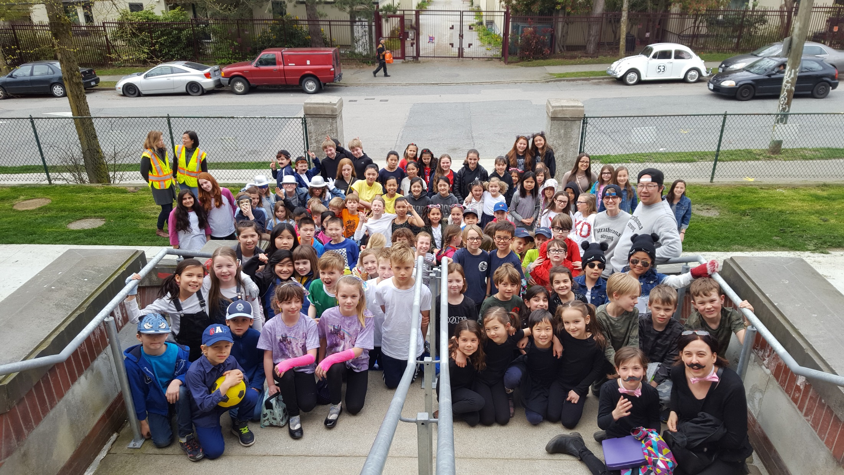

**Community Centre News**



**Cooking Fun for Families**

* Get to know other parents as you cook together and share your recipes and food skills
* Mondays during the school year, 12 – 2pm
* Free – to register, contact Tracy Kong, VSB Neighbourhood Assistant ([tkong@vsb.bc.ca](mailto:tkong@vsb.bc.ca), 604-713-4630 ext. 800218)

**Cultivating Food Cultivating Community Workshop Series**

* 2nd Friday of the month 9:30 – 11:30am
* 2 more workshops remain in the spring workshop series
  + Friday May 11: Early Summer Gardening
  + Friday June 8: Container and Windowsill Herb Gardening
* Register at the Strathcona Community Centre (or 604-713-1838 or [www.vancouver.ca/strathconarec](http://www.vancouver.ca/strathconarec)) at least 2 days in advance
* $15/workshop, plus DISCOUNTS available with Leisure Access or Strathcona Subsidy Programs!



**PAC CORNER**

Hi everyone,

We have about a month before the spring fair. Due to some higher than expected costs, the PAC had to adjust some numbers and activities. We will still be giving out 10 free tickets to every student, but we are also hoping that auxiliary ticket sales (which will commence May 14th) and donation stations will help us insure the event is at least break even.

We need volunteers for the following:

Popcorn 2 people 9 am – 2 pm, 1 pm – 7 pm

Cotton candy 4 people 9 am – 2pm, 1pm – 7 pm

Set up crew 4 people 11 am – 3pm

Clean up crew 6 people 6:30 pm – 7:30 pm

Tickets 2 people 2:45 pm – 7 pm

Hot dogs 3 people 2 pm – 7 pm

Ice cream 2:30 pm – 6:30 pm

Drinks 2 people 2:30 pm to 7 pm

Cake walk 2 people 2:30 pm to 7pm

Face Painters 6 people 3pm to 6:30 pm

If you can help out, please contact April Griffin on Facebook or by email at info@strathconapac.org

The last PAC meeting also saw the amended constitution passed. This gives the PAC a common understanding of how it will run, and more importantly will help insure volunteers can continue to support board positions if the PAC so desires without a 2 year term restriction. The PAC has a recall right to balance off any risks of the new no term limit amendment.

The next PAC meeting, May 23, will be the elections for the coming 2018-19 school year. Some positions remain vacant from the previous year and new vacancies will emerge. Please think about volunteering to be elected to the board that evening.

As I will be running for election to city government this fall, I will be stepping down from the PAC board to avoid any conflicts of interest. I just wanted to ensure that the rest of the school year finishes on track before my departure. I will continue to volunteer my time as a helper where I can but not in any decision making capacity.

It has been a pleasure and an honour serving as the chair of the Strathcona family of students, staff and parents and I wish you all continued unity and success!

Peace,

David Chen

PAC Chair