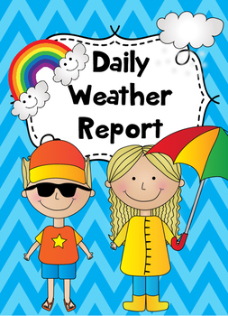

Daily Weather Report

Watch the news reporter on the Daily News. This is your new job. Prepare a daily weather report that you can announce to a real life audience in your home or video yourself and send it to your audience. Please send it to Ms. Froese at cfroese@vsb.bc.ca before 10:30 am if you would like to do the daily video tweet @LivingstoneVSB. Be sure your parents have signed the media consent form. It should be under 1 minute. It would be AWESOME to have kids doing daily weather reports.

Collect your weather data at the same time every day.
Time of daily Weather check:
___________am (after midnight) or ___________pm (past morning)

Daily Weather Temperatures:
Record the daily temperature in Vancouver.
Pick 2 other cities you may have visited or where your family or friends live and record their daily temperatures.

Temperature data from:
Option 1 – Vancouver, British Columbia, Canada

Option 2 -

Option 3 –

Daily Weather Report
Chart

Day | Date | Temperature In: Vancouver | Temperature In: | Temperature In:
Monday

Tuesday

Wednesday

Thursday

Friday

Saturday

Sunday

