

**LORD STRATHCONA ELEMENTARY**

592 East Pender Street

Vancouver, B.C. V6A 1V5

Tel: 604-713-4630 Fax: 604-713-4633

Principal: Mr. Jason Eng Vice Principal: Ms. Janine Lamb

PAC Chairperson: Mr. David Chen

**FEBRUARY NEWSLETTER**

Dear Strathcona Families,

Happy New Year (one month late) and all the best for 2018! This has been the busiest January that I have ever experienced as a school administrator. We continue to settle into our new home, and life is good post-seismic. Our staff and students feel much more connected by being in the Senior and Junior buildings, with the bridge joining the main and upper floors. Minor details and unpacking will continue in the coming weeks and months. Due to popular demand, I will be hosting a second 20 minute school tour prior to the February 7th PAC meeting at 5:30. (Please meet in the cafeteria to start). As part of our Multicultural Day event in February, we will have an “Official Opening” of the completed school, including cake! Stay tuned for details. The New Year also kicked off with a bang, due in large part to a donor project taking place at Strathcona, with educational internet safety talks taking place, a World Fair showcase, and school beautification projects being carried out by 900 Trend Micro volunteers! It was quite the event!

In the midst of all this, teaching and learning continues at a high level. I hope that effective communication between teachers and families at January’s parent-teacher and student led conferences springboards into a successful Second Term for students. Basketball season is in full gear, and kicked off with the unveiling of new uniforms. All teams will get the opportunity to wear them at some point this season. Both our Senior Boys and Girls teams represented well, finishing with a combined 6-0 record at the Britannia Cubs Tournament, bringing home two 1st Place trophies! It is amazing to see a group of athletes play together as a team, work hard, and be unselfish! Needless to say, the work done by all coaches involved is outstanding! Looking forward to the rest of the season.

I look forward to connecting with families in the coming weeks…feel free to pop by the office to chat or say hi as my door is always open!

Sincerely,

Jason Eng



**MS. HONG’S LIBRARY CORNER**

Welcome Back to the Library!

I hope you had a wonderful break. Open Book Exchange has restarted. Open Book Exchange is from 9:00 am to 9:40 am Monday to Friday. Students can come in small groups or with the whole class. See your teacher for the best days. The library is usually open before school at 8:30 am and after school until 3:30 pm.

|  |  |  |  |  |
| --- | --- | --- | --- | --- |
| **Monday** | **Tuesday** | **Wednesday** | **Thursday** | **Friday** |
| Open Book Exchange  8:30-9:00 am | Open Book Exchange  8:30-9:00 am | Open Book Exchange  8:30-9:00 am | Open Book Exchange  8:30-9:00 am  Closed 2nd Thursday of each month for meeting | Open Book Exchange  8:30-9:00 am |
| Open Book Exchange  9:00-9:40am | Open Book Exchange  9:00-9:40am | Open Book Exchange  9:00-9:40am | Open Book Exchange  9:00-9:40am | Open Book Exchange  9:00-9:40am |
| Open Book Exchange 3:00-3:30pm | Open Book Exchange 3:00-3:30pm | Open Book Exchange 3:00-3:30pm | Open Book Exchange 3:00-3:30pm | Open Book Exchange 3:00-3:30pm |
| Div.18 Tam  Book return |  |  | Div. 22F Bouchard Book return |  |

**SCHOOL WEBSITE**Slowly but surely we have begun to update our Strathcona School website. We will be posting important dates, announcements and newsletters on the site. Our goal is to move toward paperless communication with families by the end of this school year. Stay tuned!

**SCHOOL TOUR**

Interested in a tour of the school?

Come by February 7th at 5:30 PM and Mr. Eng will show you around!

**STUDENT SAFETY**

Student safety is the first priority of the Vancouver School Board. Schools will be kept open except under extreme circumstances to provide the option of attendance for all, but the decision to attend is the responsibility of each family. Parents/guardians are responsible for their children's safe travel to and from school. If, for any reason, a parent/guardian feels that a child cannot travel safely to school, then they should make other arrangements. During extreme weather conditions it is also common for police and other authorities to advise citizens to avoid unnecessary travel. Parents should take this advice as well. Students will not be penalized for lack of attendance under such poor weather conditions. Students are reminded to wear appropriate clothing for the conditions. When sidewalks and roads are slippery, students walking to school should take extra care. We encourage you to review your own preparations for severe weather conditions and ensure that you are familiar with the city’s response procedures for those conditions. We request that you strictly adhere to parking restrictions in and around all Vancouver schools.

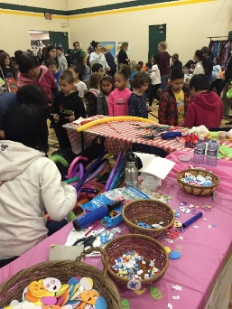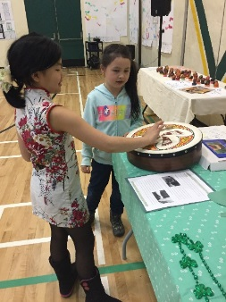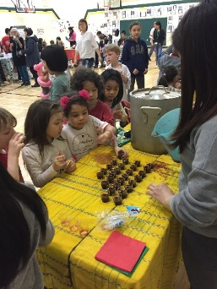**MULTICULTURAL FAIR 2018**

Mark your calendar for Thursday, February 22nd, 2018 for our Multicultural Fair!

During the school day there will be a number of festivities, including a school-wide assembly with performers from the community.

In the evening there will be an event that includes an “Official Opening” of the completed school, and cake! Details will follow closer to the date.

**LINKS PROGRAM**

Attention Grade 7’s! Free tutoring and mentoring every Thursday in the Activity Room at Strathcona Community Centre from 3:15 PM to 5:30 PM or the Cafeteria at Strathcona Elementary from 6:30 to 7:30 PM. Contact (604) 360-5812 or email [swalker@pcrs.ca](mailto:swalker@pcrs.ca) for more information.

**LUNCH TIME PROGRAMS**

New programs for students during Lunch Time:

Tuesdays – Basketball with Wayne, Grade 4-5 (Gym)

Wednesdays – Knitting with Helen, Grade 4-7 (Library)

Wednesdays – Soccer with Marvin, all ages (Gravel Field)

Thursdays – Basketball with Wayne, Grade 6-7 (Gym)

Fridays – Lego Club with Ryan, all ages (Library)

**PEER CONFLICT, MEAN BEHAVIOUR AND BULLYING**

*What’s the difference?*

When a child is having a problem with her or his peers, it can be hard for parents to know what is really happening – is it bullying? Or is it something else?

Each type of behaviour must be handled differently, to keep children safe and help them learn how to get along with others.

**Peer Conflict**

Conflict between and among peers is a natural part of growing up. Children will have times when they disagree and can’t solve their own problems. They may even become so frustrated that they say mean things or act out physically by hitting, kicking or trying to hurt.

If it’s peer conflict you will be aware that these children:

* usually choose to play or hang out together;
* have equal power (similar age, size, social status, etc.);
* are equally upset;
* are both interested in the outcome; and
* will be able to work things out with adult help (after calming down).

Adults can respond by helping the children talk it out, and see each other’s perspective. This is often referred to as “conflict resolution”.

**Mean Behaviour**

Children may try out behaviours to assert themselves – sometimes saying or doing mean things – such as making fun of others, using a hurtful name, taking something without permission, leaving a child out, or “budging” in line.

If it is mean behavior, usually:

* it is not planned and seems to happen spontaneously or by chance;
* it may be aimed at any child nearby;
* the child being mean may feel badly when an adult points out the harm they’ve caused.

When adults see mean behavior they should not ignore it. Adults should respond quickly, firmly and respectfully to stop the behavior, to let kids know that their actions are hurtful and to re-direct children to more positive behaviour.

This quick response stops children from developing a pattern of mean behaviour as their way of interacting with peers, and prevents mean behavior from escalating into bullying. It is a lot easier to correct a child for one nasty comment than to change a pattern of cruelty that grows over time.

**Bullying Behaviour**

Bullying is serious behavior that has three key features – all three must be present for the situation to be considered bullying:

* Power imbalance -- One child clearly has power over the other(s), which may be due to age, size, social status, and so on.
* Intention to harm -- The purpose of the bullying behaviour is to harm or hurt other(s) – it’s intended to be mean and is clearly not accidental.
* Repeated over time -- bullying behaviour continues over time, and gets worse with repetition. There is a real or implied threat that the behaviour will not stop, and in fact will become even more serious.

The effect on the child who is being bullied is increased fear, apprehension, and distress. Often by the time adults find out about what is happening, the child has tried many ways to stop the bullying but cannot do so on their own.

Adults must address the bullying behaviour and ensure the safety of the student who has been targeted. They also need to reassure the children who may have witnessed the behaviour that adults are taking care of it.

When schools respond to bullying, staff will also help the child who has been bullying others to take responsibility for their actions, and change their behaviour. They will monitor the situation to ensure the bullying stops, and will support the child who has been bullied to regain confidence and a sense of safety. Staff may follow-up with the students who observed the behaviour to help them learn what to do when they see bullying.

The “conflict resolution” style of bringing the children together is not recommended in bullying situations, until considerable time has gone by and all children are feeling safe enough to talk about what happened so that relationships can be healed.

**KINDERGARTEN REGISTRATION FAQs**

**What if I want to apply for an English school in another catchment area?**

If you are interested in having your child attend an English school that is not your catchment school you will need to submit a cross-boundary application. The cross-boundary process opens February 1st. The deadline for cross-boundary application is February 28th. If you are applying to a school outside your catchment area, it is important for you to know that your child will only be considered once all in-catchment students have been placed.

**What if I want to apply for a choice program?**

The district offers a variety of choice programs including French Immersion, Mandarin Immersion, Fine Arts, Aboriginal Focus School, International Baccalaureate and Montessori. If you are planning to apply for Choice Program(s) you still need to register for kindergarten at your English catchment school first. The online application process opens in mid-January and closes in early February. Visit http://kchoice.vsb.bc.ca for more information. There will be a district supervised draw to select applicants for the available program space. Offers for program spaces will be made by late February. You will be given a formal offer of a space in a Kindergarten choice program or an indication of where you sit on the waitlist.

For those families interested in applying for a French Immersion kindergarten placement for 2018-2019 school year only, please be advised that the District has removed Priority Registration Zones (French Immersion catchments).  This means that parents can choose to apply to any of the 13 VSB elementary schools offering French Immersion (maximum 3 choices per student). Applications are made online.



**Have you heard of Intensive French?**

Intensive French (IF) is a two year second language teaching approach beginning in Gr 6 in which French is taught intensively for most of the day during five months in Grade 6. The students in the program receive about 80% of their instructional day learning French during the first half of the year and 20% during the second half. The rest of the curriculum (except for Mathematics) is “compressed” into the second half of the year. Classroom activities are related to projects and there is a high degree of interaction between teacher and students, as well as among students. Emphasis is put on oral language and interaction between students.

For more information on this program /Open House - please go to the VSB website, under Registration select Intensive French: Gr 6&7 (www.vsb.bc.ca/programs/intensive-french-grade-6-and7). The Intensive French program is offered in three schools, Brock, Franklin and Fleming, and is open to all students in the District. Please contact the school if you have further questions.

Brock 4860 Main St. 604-713-5245

Fleming 1401 East 49th Avenue 604-713-4793

Franklin 250 S. Skeena Street 604-713-4709

**KINDERGARTEN SEPTEMBER 2018**

Kindergarten can be an exciting and stressful time for you and your child.

Support for School Success invites families who have a child entering kindergarten to join in fun activities to provide support for learning, behaviour and physical health.

With fun activities, your child will have eyes, hearing, talking, health, behavior, and dental checks.

Location: Dates:

Ray-Cam Co-operative Centre February 28, March 28,

920 East Hastings Street April 25, May 23, June 27

Call Harinder at 604-675-3980 to sign up for a 2 hour appointment.

For more information:

Ray-Cam staff - Carin @ 604-257-6949;

BC Children’s Hospital RICHER NPs @ 604-875-2246

OR Drop in to check things out!

You can bring a friend or family member with you for support.

There will be a snack, lunch and a small gift bag for your child.

MARK YOUR CALENDARS



**WHAT’S GOING ON AT STRATHCONA**

|  |  |
| --- | --- |
| Monday, February 12th | Family Day, school not in session |
| Monday, February 19th | Pro-D Day, school not in session |
| Thursday, February 22nd | Multicultural Fair |
| Wednesday, February 28th | Anti-Bullying Day (Pink Day) |
| Wednesday, March 14th | Report cards (for those not involved in the CSL Pilot Project) |
| Monday, March 19th – 30th | Spring Vacation, school not in session |
| Monday, April 2nd | Easter Monday, school not in session |
| Tuesday, April 3rd | School re-opens |

**STUDENT SHOWCASE**



**DIVISION 11**

On December 6, 2017, Division 11 went to Grouse Mountain, Peak of Christmas celebrations. We took the school bus to the mountain and were greeted by our tour guide, Jim. We went snow shoeing in the trails. Some of us fell down, but the special shoes made us less slippery. Then we saw the bears hibernating in the den. Did you know, the bears do not eat or drink for 150 days! We had lunch at a beautiful restaurant on top of the mountain and then had a real sleigh ride. This was the best field trip ever!

Keyana, Abigail, Anders, Samarah

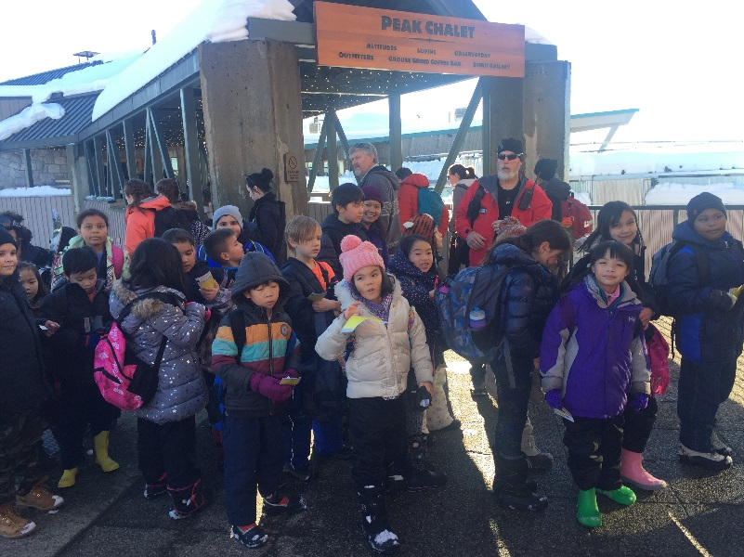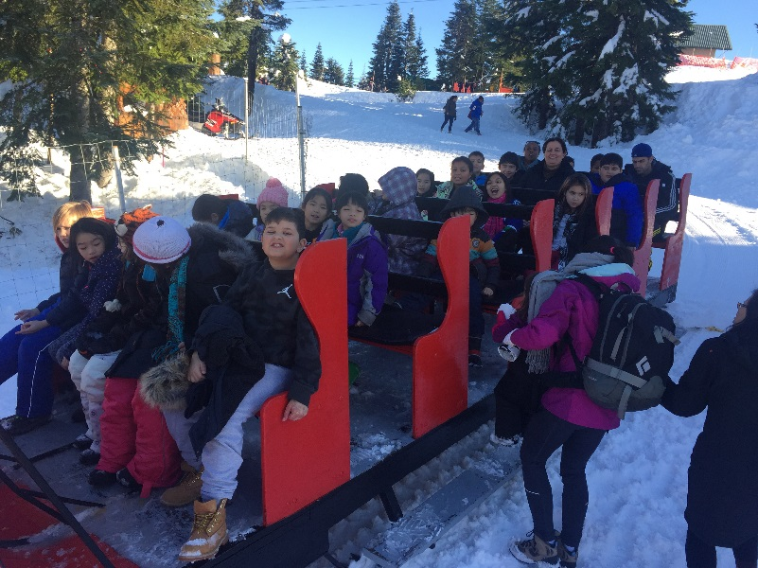 Div. 11



**PAC CORNER**

Happy new year everyone! I trust everyone had at least a few moments to unwind and enjoy with your loved ones. We are now in the bottom half of the school year. To insure we have smooth sailing with some of the events that are coming up, I thought it would be best to have a list of events on the go.

|  |  |
| --- | --- |
| Feb. 7  6 PM  Cafeteria | General meeting in the cafeteria. Repeat of the school tour by Mr. Eng at 5:30 PM. Dinner starts at 6 PM, meeting starts at 6:30 PM. Dinner and childcare provided. Official notice of draft change of the PAC constitution. |
| Feb. 16  6 PM | Movie Night (and maybe Toy Swap)  Diary of a Wimpy Kid  Concession opens at 5:30 PM. Please return concession order forms before then! |
| Apr. 11  6 PM  Cafeteria | PAC general meeting in cafeteria. Dinner starts at 6 PM, meeting starts at 6:30 PM. Dinner and childcare provided. Vote on the draft change of PAC constitution. |
| May 23  6 PM  Cafeteria | PAC general meeting in the cafeteria. Dinner starts at 6 PM, meeting starts at 6:30 PM. Dinner and childcare provided. Elections for 2018-2019 PAC board. |
| May 31  3 PM – 6 PM  Gym | Spring fair in the gym from 3 PM – 6 PM. |

The spring fair will be held later than usual in the hopes of capturing better weather, experimenting with more outdoor operation of the venue, and reducing stress from overcrowding indoors.

As voted on by the PAC, this year we will be experimenting with 13 free tickets per enrolled student to the spring fair, as budgeting may not be so easy for families due to the later date. This will insure that the event is inclusive of every student. Those not enrolled in the school may still purchase tickets to join us.

If you have suggestions, concerns, or even praise (every volunteer likes that occasionally), please email the PAC at [info@strathconapac.org](mailto:info@strathconapac.org).

See you at the next function!

David Chen

PAC Chair