

**LORD STRATHCONA ELEMENTARY**

592 East Pender Street

Vancouver, B.C. V6A 1V5

Tel: 604-713-4630 Fax: 604-713-4633

Principal: Mr. Jason Eng Vice Principal: Ms. Janine Lamb

PAC Chairperson: Mr. David Chen

**MARCH NEWSLETTER**

Dear Strathcona Families,

I hope the last wave of winter is close to being behind us and we can focus on spring and better weather! One of the marquee events on the yearly Strathcona calendar is Multicultural Day. During this year’s February 22nd event we had our Multicultural Fair, afternoon assembly, and evening food tasting event. This day truly represents everything that is Strathcona. I love how students, staff, families and community partners come together to celebrate all the diversity that exists in our school and community. Thank-you to all who contributed: families and community members who set up booths at the fair, student presenters, dance groups led by Anne-Michelle, our Kindergarten Lion Dancers and of course the many volunteers who helped make the day a success! It was great to connect with everyone that evening at the food tasting. Thank-you for braving the elements and coming out to socialize, connect and celebrate the school reopening! Hopefully you got a slice of cake!

There have been several opportunities for our whole school to come together in recent weeks to see performances, attend field trips, and also have in depth discussions about the Strathcona School Code of Conduct: Take Care of Myself, Take Care of Others, Take Care of Our Community. Pink Day celebrations on February 28th at Strathcona serve as an excellent reflection of how students and staff follow the Code of Conduct and also stand up against bullying, discrimination, and homophobia. Strathcona is an inclusive school community that celebrates diversity.

In the coming weeks leading up to Spring Break, I look forward to reading report cards to get a better snapshot of the learning taking place in classrooms. I hope that you find some time to have meaningful conversations around your child’s learning and progress over the past three months.

If I do not connect with you in person over the next two weeks, I wish everyone at safe and relaxing Spring Break!

Sincerely,

Jason Eng

Principal

**MS. HONG’S LIBRARY CORNER**Reading at home with your children is fun and helps their literacy development. If you have internet access, try this website: http://www.storybookscanada.ca/.  
The books are from many cultures and are available in many languages, including English, Cantonese, Mandarin, Spanish, Tagalog, and Punjabi. You can read the words or have the book read aloud to you.



**SPRING BREAK**The last day of attendance prior to our two-week break is FRIDAY, MARCH 16.  
School is not in session the week of MARCH 19 or MARCH 26.   
The first day back to school following our two-week break is TUESDAY, APRIL 3, 2018.

**CHANGE OF ADDRESS OR PHONE NUMBER?**Just a reminder that if you have changed your address or telephone number, you must contact the school office with this new information. Please provide a copy of your lease/rental/purchase agreement for the student’s record. For safety and enrolment purposes, it is vital that the school office has this information.

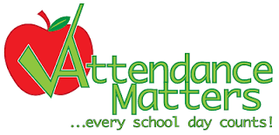**DAILY ATTENDANCE**Daily school attendance is important for all students. Students who attend school regularly are more engaged in learning, have a greater sense of belonging to the community and are more likely to graduate high school. Perfect attendance should be a goal because even missing two days of school a month works out to a student missing the equivalent of one month of school a year. Research shows that 18 school days missed can lead to one grade lost. Your child should attend school every day unless there is an unavoidable cause like illness.   
When children arrive at school on time they start the day off more positively. When children attend school consistently, they are able to build stronger relationships with their teachers and classmates. It is difficult to ‘catch children up’ when they miss a significant amount of teacher instruction because of late arrivals. In some cases, valuable teacher time can also be compromised and these late arrivals/absences impact the learning not only of the child who is absent/late but also of his/her classmates.   
Please let us know if there is any way we can support you in getting your child to school. Please contact us in the office 604-713-4630 to discuss your ideas or concerns.

**ENGLISH KINDERGARTEN REGISTRATION FOR SEPTEMBER 2018**We have spaces left in our English Kindergarten classes for September 2018. If you have a child born in 2013, please register them ASAP in order to help secure your child’s placement in their home school. Once classes are full, new Kindergarten registrants will be placed on a waitlist. Application/registration forms are available in the school office. Bring your child’s birth certificate, care card, proof of residence (rental/lease agreement or property tax/home ownership papers) and immunization records with you when you register.

**STRATHCONA WELCOME TO KINDERGARTEN EVENT**

If you have a child entering Kindergarten at Strathcona in September 2018, please join us on Wednesday, April 11th at 10:15 AM in the Auditorium. You and your child will have an opportunity to meet the Kindergarten teachers, learn more about Strathcona Elementary, and participate in some fun learning activities. At the end of the event, you will take home a ‘Welcome to Kindergarten’ bag filled with supplies, for example, books, crayons, paper and scissors.

**KINDERGARTEN SEPTEMBER 2018**

Kindergarten can be an exciting and stressful time for you and your child.

Support for School Success invites families who have a child entering kindergarten to join in fun activities to provide support for learning, behaviour and physical health.

With fun activities, your child will have eyes, hearing, talking, health, behavior, and dental checks.

Location: Dates:

Ray-Cam Co-operative Centre March 28, April 25

920 East Hastings Street May 23, June 27

Call Harinder at 604-675-3980 to sign up for a 2 hour appointment.

For more information:

Ray-Cam staff - Carin @ 604-257-6949;

BC Children’s Hospital RICHER NPs @ 604-875-2246

OR Drop in to check things out!

You can bring a friend or family member with you for support.

There will be a snack, lunch and a small gift bag for your child.

MARK YOUR CALENDARS



**WHAT’S GOING ON AT STRATHCONA**

|  |  |
| --- | --- |
| Wednesday, March 14th | Report cards (for those not involved in the CSL Pilot Project) |
| Monday, March 19th – 30th | Spring Vacation, school not in session |
| Monday, April 2nd | Easter Monday, school not in session |
| Tuesday, April 3rd | School re-opens |
| Thursday, April 5th | Class/Team/Club Photos |
| Wednesday, April 11th | Welcome to Kindergarten Event (10:15 - 12:00 PM) |
| Wednesday, April 25th | Spring Concert (Evening Performance) |
| Thursday, April 26th | Spring Concert (Daytime Performance) |
| Friday, April 27th | Pro-D Day, school not in session |

**STUDENT SHOWCASE**



**MULTICULTURAL FAIR**

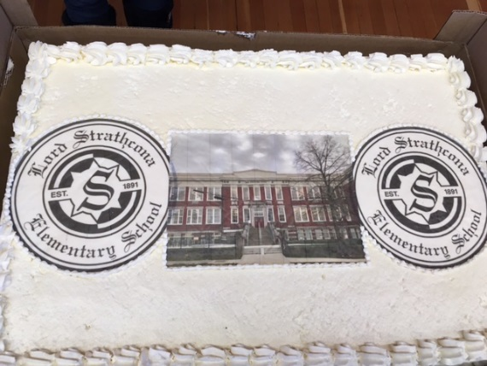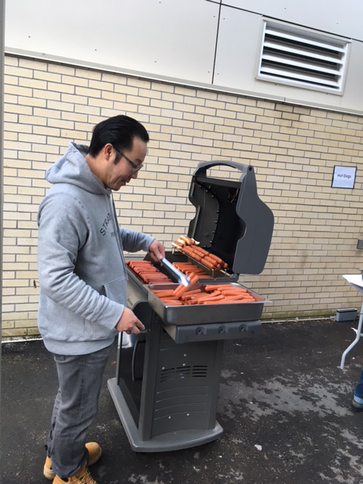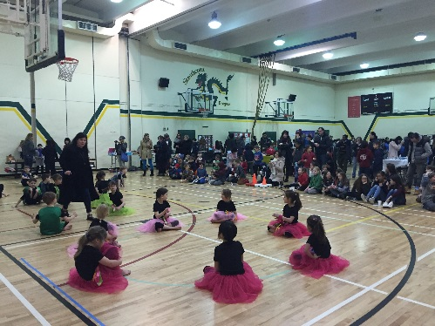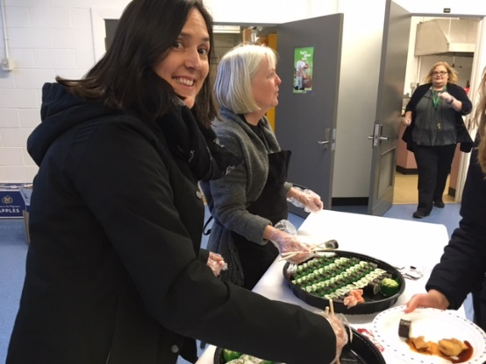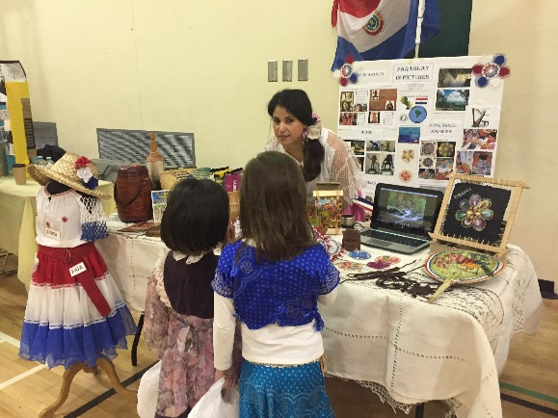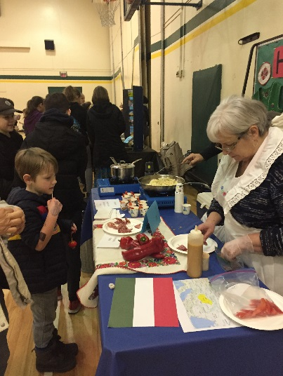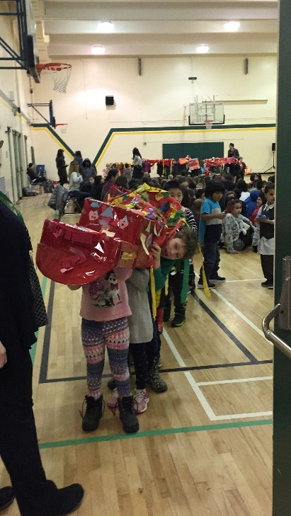Many thanks to all the staff, students, families, volunteers, and community members who put their tremendous efforts and continual support in making this year’s Multicultural Fair another successful and meaningful event! Here are some highlights of the day!

**Community Centre News**





**WORLD RUGBY SEVENS SERIES TEAM VISIT**

The Community Centre is excited to confirm that the Strathcona Elementary School will be hosting members of the Spanish Sevens Team as part of the 2018 HSBC Canada Sevens Community Visit Program!

Location: Strathcona Elementary School

Date: Wednesday, March 7th

Time: 3:30pm – 4:30pm

**FOOD SECURITY PROGRAM UPDATES**

**Breakfast Program** will be open with reduced hours throughout spring break!

* For all Lord Strathcona Elementary students and their families
* Free for students, suggested donation for parents
* Monday to Friday, 8 - 9am

**Backpack Program** will be closed over spring break

* Closed on Friday March 23 & Friday March 30
* Contact Lorraine or Lauren at the Food Security Office (604-713-1839) if you would like information about other community food resources to access during this time

**Cooking Fun for Families** weekly community kitchen for parents of Strathcona Elementary students

* Get to know some other parents in the school while also sharing recipes and food skills
* Mondays during the school year, 12 – 2pm
* Free – to register, contact Tracy Kong, VSB Neighbourhood Assistant (tkong@vsb.bc.ca, 604-713-4630 ext. 800218)

**Native Edibles Talk and Walk** workshop coming up on March 27th 6-7:30PM

* Family-friendly, all children must be accompanied by a caregiver and able to participate in a classroom setting and outdoor walk
* Discounts available for those in the Leisure Access or Strathcona Subsidy Programs (http://vancouver.ca/parks-recreation-culture/strathcona-recreation-subsidy.aspx)
* PRE-REGISTER with the Strathcona Community Centre by March 24th (in person, 604-713-1838, www.vancouver.ca/strathconarec)

**Pick-up a spring brochure** at the community centre’s front desk or look online (www.vancouver.ca/strathconarec) for more spring programming

* Community Kitchens
* More workshops
* Strawberry picking
* Canning club…

**CITY OPERA AT STRATHCONA COMMUNITY CENTRE**

Please join us for our first free concert in Strathcona, made possible by the generous support of CREATIVE BC and the Province of British Columbia.

On Friday, April 20th, 2018, from 7 – 8 pm, hear soprano Michelle Koebke and pianist Roger Parton in a concert of opera and Broadway standards - with excursions into Chinese folk song. Free, of course, and please register at Strathcona Community Centre.



**PAC CORNER**

We are now heading into the final stretch of the year. We just completed another movie night. Numbers attending were down and we were a bit disappointed that some food order forms seemed to have been returned strictly to get a free draw ticket, and as a result, too much food was purchased for the event. Given the tight resources, it is very important that we get accurate estimates of attendance and needs so that we do not significantly over-purchase perishable supplies.

As we move into the final stretch, the PAC voted to accept the new constitution draft for consideration to be voted on at a future meeting. This draft makes the language consistent and updates the PAC’s needs as it evolves into future operations.

Our last event of the year is the spring fair. It will be held on May 31. A few significant changes:

* Every registered student will get 13 complimentary tickets to the fair
* The delayed time will hopefully allow for parts of the fair to be held outside so we can enjoy the sunshine and diffuse the crowds (a huge deterrent for some parents)
* New games will be brought in

Due to storage limitations, all remaining fair prizes from previous years will be used up this year.

If you are planning to attend with children who are not enrolled in the school, fair tickets will be available for purchase.

Coffee Wednesdays will continue shortly. Volunteers are needed to assist with Coffee Wednesdays and the upcoming spring fair. Please contact April Griffin if you are interested in helping out.

Lastly, the school received a generous donation from the District PAC as an encouragement for tier 1 school parents to get involved. The grant is specifically targeted to be used to engage parent participation with the PAC, and no other purpose is allowed.

The next PAC meeting is Wednesday, April 11 at 6 pm. See you then.

Warm regards,   
  
David Chen