ORCAS on the Playground
EVERYWHERE | SWINGS | SLIDE | SKIPPING | FIELD | 4 SQUARE
- Follow the ORCAS Code of Conduct  - Solve problems peacefully – find an adult if you need help | - Sit properly  - Swing back and forth, not side to side  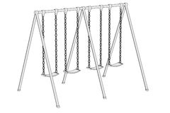  - Take turns, counting to 100 in the designated area. | - Slide down on your bottom, feet first  - Line up nicely while waiting  - Clear the landing area right away | - Use skipping ropes for skipping!  - Make sure you find an open space so no one gets hit with the ropes | - Play ball games on the field  - All games go east to west | - Play Fairly  - Include others in the game and take turns

