Laurier PAC Lunar New Year Culture Sharing Potluck & Family Movie Night – Wonder Thurs Feb 15 Potluck 5 pm movie 6 pm
Thursday February 15th please join us for a Lunar/ Chinese New Year Culture Sharing Potluck followed by the movie Wonder. We know there are many in our school community who celebrate the lunar New Year and we would like to share the celebration. Please use the form below to tell us how you celebrate and we will have some posters about each celebration. For the potluck please bring your family and a dish to share (peanut free please). If possible, please bring your own reusable cutlery and dishes. ***We are looking for volunteers to help out. If you can help, please fill out the bottom of this form and send back to school. ***
Thanks Sir Wilfrid Laurier Elementary PAC
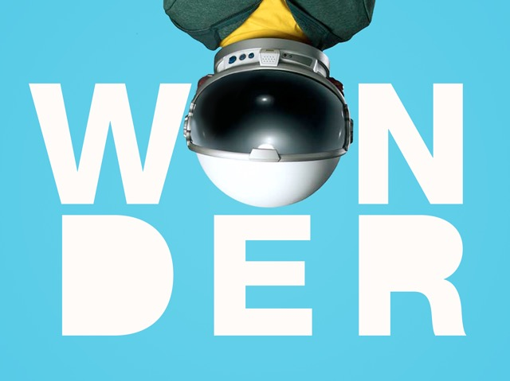
Sir Wilfrid Laurier Elementary PAC is excited to invite Laurier students and their families to
“Wonder” Thursday February 15, 2018. 6:00 pm
Seating will be on mats, so you may bring blankets/pillows to make yourself comfortable
Admission by donation (suggested donation $2/per person to cover the cost of the movie licence)
Parents please note that you are responsible for supervising your child.
This is NOT a drop-off event.

------------------------------PLEASE RETURN THIS TEAR OFF TO THE SCHOOL OFFICE BY Friday, Feb 9th --------------------------------------

At the lunar new year my family celebrates:_______________________________________________________________
YES! I can help on Thursday, Feb 15th (please check your choice) :
□ Set Up Tables and Chairs for Potluck □ Cleanup after Potluck
□ Planning and organizing movie concession (pizza, drinks, snacks, other) □ Concession during movie □ Cleanup after movie □ Creating Culture Sharing Posters (week before event) □ Other _____________________________________

Name: ___________________________________Student`s Name: ______________________________
Contact Phone number or email (for volunteering): __________________________________________ Suggestions: __________________________________________

