Norma Rose Point School

Circle of Courage

Code of Conduct

BC Human Rights Code

Norma Rose Point School promotes the values expressed in the BC Human Rights Code respecting the rights of all individuals in accordance with the law—prohibiting discrimination based on race, colour, ancestry, place of origin, religion, marital status, family status, physical or mental disability, sex or sexual orientation—in respect of discriminatory publication and discrimination in accommodation, service and facility in the school environment.

Statement of Purpose

“Learners at the Centre”

Our code has adopted an aboriginal medicine wheel concept called the Circle of Courage which emphasizes social and emotional growth in one’s life. Research shows that children who are socially and emotionally healthy are the best learners; children who display positive social-emotional traits are successful in school. As the Circle of Courage proposes, it is important for children to grow and develop in four domains.
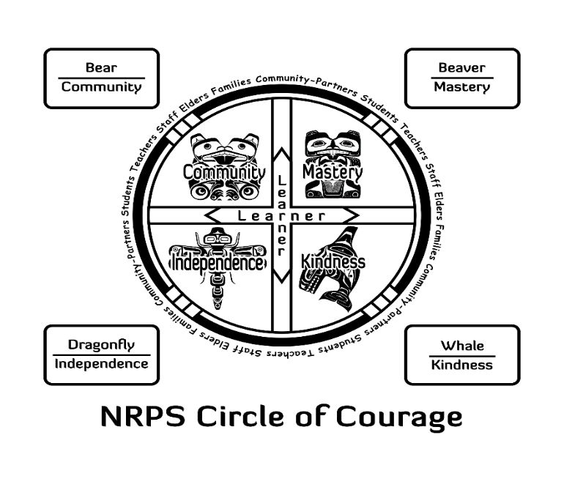
Expectations of Student Conduct
Each domain carries with it some guiding principles. Additionally, we have included animals from Coast Salish tradition which symbolize the same qualities.
Trait & Animal | Qualities
Mastery Beaver | Come to school ready to learn and always do your best  Eat nutritious food, get lots of exercise, and plenty of rest  Set personal goals and make plans to achieve them  Take pride in your achievements and celebrate growth
Independence Dragonfly | Be accountable for your actions and lead by example  Know yourself - be a self-regulated learner  Be a creative, critical, and flexible thinker
Community  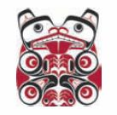  Bear | Respect and take care of our environment  Be helpful and cooperative with adults and other students at school, at home, and in our community  Stand up against injustice - report behaviour that is unsafe, disrespectful, or bullying  Solve problems in a fair and peaceful manner
Kindness Whale | Be generous with your time, materials, and talents  Care about the feelings of others and help those who are hurt or in need  Respect the feelings, rights, and bodies of others  Give people their space when they need it for thinking, learning, and working  Be inclusive and welcoming, make sure no one feels left out  Treat others as you want to be treated

Students are expected to conduct themselves in constructive and helpful ways. Refer to the chart above for guiding behaviours that are acceptable.

Expected Behaviour of our students:

In the classroom and library
- Be on time, prepared for class and on task
- Listen and speak to others with respect
- Treat all staff and guests with respect by listening,
- Following directions and speaking through kindness
- Your teacher should always know where you are
- Respect one’s own and others’ property
- Respect the Internet Policy

During Lunch Time
- Eat nutritious food and clean up after yourself
- Do not bring nut products
- Get lots of exercise
- Use please and thank you
- Stay seated while eating
- Use quiet voices

On the playground
- Include others in your play. Make sure no one feels left out.
- Play safely
- Care about the feelings of others
- Give people their space if they need it
- Work to solve problems peacefully
- Take responsibility for your actions
- Stay on school grounds and in designated areas
- Keep hands, feet and unkind words to yourself
- Solve problems by talking and/or seeking help
- Stand up against behaviour that is unsafe, disrespectful or bullying

In the washroom
- You are there to go to the washroom
- Flush the toilet, wash your hands and turn off the taps
- Throw paper towels in the garbage only
- Report problems to an adult

Everywhere
- Demonstrate respect and manners
- Be proud of your school and community
- Treat all equipment and materials with care
- Always respect other people’s property
- Dress appropriately for school
- Do not discriminate based on race, colour, ancestry etc. (see BC Human Rights Code at the top of this document)
Consequences for failing to comply with behavioural expectations:
When students demonstrate behaviour that is not in keeping with the ideas described above, a discipline response that is based on learning and restoration (making amends) is implemented. At Norma Rose Point we reflect upon our choices, take responsibility for our actions, and make amends through a restorative action plan with consideration of the developmental levels, age, maturity and special needs of students. These expectations apply to behaviour at school, at school-related activities, and in other circumstances that impact the safe, caring and orderly environment of the school.

Level 1: When a Child Breaks the Code of Conduct
Sometimes kids make mistakes; it’s a natural part of the learning process. At these times, we aim to acknowledge and learn from these mistakes.

Some examples include, but are not limited to:
- Interfering with the learning of others
- Creating unsafe conditions (running in halls, rough-housing, throwing snowballs, and riding bicycles, skateboards, scooters or in-line skates on school property)
- Disrespecting others (name calling, swearing, teasing)
- Not respecting property (littering, ripping or writing on someone else’s work or school property)

Most of these choices are minor and can be solved with the teacher and student(s) and may involve a small group or class meeting. A review of the Circle of Courage’s qualities may be part of the restorative plan along with a decision - made with the student and the teacher - about appropriate restorative action (apology, act that gives back to the individual/school).
Level 2: When a Child Repeatedly Breaks the Code of Conduct
We believe that choices are an important part in a child’s development and, regrettably, sometimes children make poor choices. When a student at Norma Rose Point School presents a repeated pattern of poor choices we find it necessary to proceed to Level 2 interventions. At this point a discussion takes place with the student, teacher and principal. The qualities from the Circle of Courage are reviewed with the student so s/he can assess his/her mistakes. A collaborative decision will be made about appropriate restorative action and the student completes a “Make Amends Plan”, which is sent home. The teacher or principal may also request a meeting with the parents (or vice-versa).

Level 3: When a Child Breaks the Code of Conduct in a Serious Way
Norma Rose Point values children in the highest regard. Our desire is to educate the whole child. Sometimes children face conflicts to which they are not equipped to emotionally capable of effectively dealing with. The Circle of Courage presents opportunities for children to learn how to deal with conflict in their lives. It is often during these bouts of conflict that children act in ways that are inappropriate or unacceptable.
Some examples include, but are not limited to:
- Bullying, harassment, intimidation or threats
- Ignoring others who bully, harass, intimidate or threat rather than seeking help
- Racist, homophobic or sexist comments/behaviour
- Theft
- Non-compliance; wilful disrespect
- Very unsafe behaviour (leaving school grounds/class)
- Vandalism (wilful destruction of property)
- Using physical violence
- Accessing inappropriate sites on the Internet
- Saying mean things about others in person or via e-mails or blogs
- Playing pranks on others
Restitution may take place by way of communication between the teacher(s), parent(s), student, and principal to devise the next level of intervention for the student to succeed in school. A decision will be made about the appropriate restorative action and the student completes a “Personal Agreement” which is sent home for the parents to see or sign.
Serious Breaches of the Code of Conduct
Choices that are made by students (such as weapon offences, violent behaviour causing injury to another person, lighting fires, stealing, or a major disruption in a classroom or school event) may result in an in-school or out-of-school suspension for up to five days. The authority to suspend students is given to the principal of the school. Please note that if there is a violation of a very serious nature, suspension will be immediate. In such circumstances, a letter will be placed in the child’s file. A conference with the student, parents, teacher and principal is required before the student can return to school. It may be necessary to contact others outside of the school such as district staff, police, MCFD or other community agencies.

Suspensions
In accordance with the School Act, Sec. 85(2)(ii) and (d), the Board authorizes the Principal or designate of any school in the district to suspend a student from attendance at school for up to five days.
Suspensions may be for the following reasons:
- because a student is willfully and repeatedly disrespectful to a teacher or to any other employee of the Board carrying out responsibilities approved by the Board.
- because the behaviour of the student breaches the District Code of Conduct or policy and/or has a harmful effect on others or the learning environment of the school.
- because the student has failed to comply with the School Code of Conduct.
Suspensions over five days are made in consultation with the appropriate Director of Instruction as per District Policy (http://www.vsb.bc.ca/district-policy/jgd-r-district-student-code-conduct-regulation)

Family Involvement
Norma Rose Point’s Code of Conduct was established to ensure each child and staff member’s safety. We ask for student and parental support in honouring our commitment to ensuring the safest learning environment for all. Parents can help in the following ways:
- Discuss the Code of Conduct with your child.
- Be in close contact with your child’s teacher.
- Questions? Please phone the school at 604-713-5950.
Any of the following people would be pleased to assist you:

- Your child’s teacher
- Ms. Cam Spirli, Office Administrative Assistant
- Ms. Lily Guo, Office Support
- Ms. Karen Rommel, Area Counsellor
- Ms. Teena Smith, Vice-Principal
- Mr. Ian Cannon, Principal

