Terminology
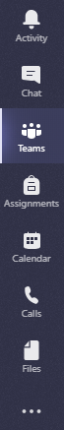
Side Navigation Bar – This gets you to all the features available in Office 365 – Teams
Activity – This is where all the activity in your Teams Classroom or if you belong to more than one Teams Classroom, is recorded. When there is a red dot, there has been new activity that you have not seen.
Chat – This feature has been disabled for VSB students.
Teams – This is where you will find all the Teams Classrooms you belong to.
Assignments – All your assignments will appear here if your teacher uses Teams for assignments. You will have to choose the correct Teams Classroom if you belong to more than one. If you can’t find any assignments here, check myBluePrint.
Calendar – This calendar is your personal calendar. It is linked to the one in your Outlook email app. If you use your calendar, all your appointments and assignment due dates will show up here. If your teacher schedules a meeting, this is where you can check where it is and where you will always find the link to join the meeting.
Calls – Use this button to call your teacher or another student to chat. Please call only other students in your class or someone you are good friends with. Do not call someone just because you found their name through the search bar.
Files – Click on this to see all your recently viewed files.
Anywhere you see … there will be “more actions”. You likely won’t need the one on the side navigation bar.

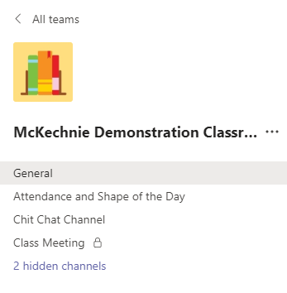
Finding your way around your classroom
- The list under your classroom name are Channels. This is how your classroom is organized.

- A lock means this is a channel only you and other students who were invited can see. Your teacher might use it for class meetings, or reading groups, or for small group work. A resource teacher might set one up for you to get extra help. Don’t worry, nobody else knows this channel is there except for the students invited to the private channel.
1
2
- Hidden channels are more channels in your classroom. You can make them “Show” if you want so that you see everything in your classroom. This is a good idea.
3
If any of your channels are bold, that means something new was posted in it.
Guidelines
- Every class has a General channel.

- Keep the “Chit Chat” in the Channel that your teacher has created for your class to talk amongst yourselves if there is such channel. Keep the conversation friendly and remember that teasing is very difficult to “get” when you are online. 70% of communication is in our body language & facial expressions and we don’t have that when we are online.

Please do not post randomly in different channels of your classroom. That is like calling out during class. It is distracting and makes it hard to pay attention to what is important. Keep the talking to your friends in the Chit Chat channel or the Chatter Box channel. Any teacher in your Teams classroom or Mme Stella or Mme Eve can delete inappropriate posts by students.

- Using @mention – you can alert someone that you have posted something you want him or her to see. Just type “@” and then their name. Please do not do this for teachers unless it is really important. Your teacher will get a notification each time you do it.
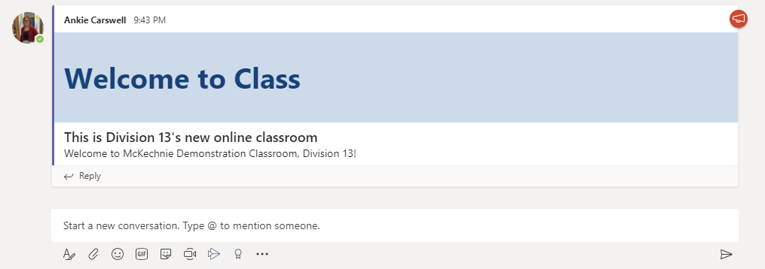
b
a
- This is an example of a Post. You may need to make a post when you have a question or comment. I made this one as an announcement. That is why there is a big blue header.
  - To keep the conversation going, use the “Reply” bar. This will keep everything about one question or topic together.
  - If you have a new question, comment or topic, use the “Start a new conversation.” bar.

- Using the tools for a new conversation.
i ii iii iv v vi vii viii ix

In order, these icons mean:
- Format – click on this to be able to write your message just like an email. If you don’t, every time you press “Enter”, it will post whatever you have typed.
- Attach – you are able to attach files to your post by using this button.
- Emojis – you know what emojis are…
- GIFs – these are animated pictures
- Stickers – pictures and memes
- Meet now – whichever channel you are in, if you click the video camera, you will start a meeting. Please do not do this unless your teacher asks you to.
- Stream – this fancy arrow allows you to upload a movie from Microsoft Stream. It is not like attaching a regular video. It only works if you created the movie in Stream.
- Praise – this ribbon makes an award
- … - this lets you use other apps to create a post.

Top Tabs
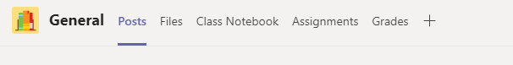
In every channel along the top, you will find the Top Tabs. Your teachers will put important apps that you need to use, up there for you. Most of the time, you will need to use the Posts, Files or Assignments top tabs.
Posts – You’ll find all the conversations between your teachers and you here. Each channel has it’s own conversations.
Files – These are all the files that your teacher has uploaded to the channel. You can look at them there if you need. Remember not to change it or you will change it in the File for everybody.
Assignments – this is where you will find the assignments for all the different channels. It is the same as using the assignment button on the side navigation bar.

Each channel has different POSTS and FILES. If you don’t find what you are looking for, try using the SEARCH bar at the top of the screen. It will search all your channels & Teams Classrooms as well as all the conversations & files.

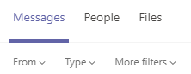
The search results will show up where your Team and channels normally appear. Click the category where you want to see the results. If you were looking for a File, click file. If you remember your teacher posting it, or it was a topic of conversation, select Messages.

More Help!
If you have any difficulty, please ask your teacher for help. Further reference and how-to guides can be found here or on the Microsoft Teams site.

