MCBRIDE PARKING INFO

In the recent weeks, it has come to the staff’s attention that there is a significant safety issue with before and after school drop off with vehicles, which has been compounded by the COVID protocols. There are many parents who are parking in no stop areas and idling in their cars both in the morning and after school. As well as several drivers pulling U-turns on our busy streets. Due to the safety risks that this poses for our students and community we will be supervising all the areas where unsafe stopping/idling are prohibited. (no stopping means no stopping for any amount of time) NO PARKING ZONES MEAN A FIVE MIN MAX DROP OFF AND PICK UP. . https://vancouver.ca/streets-transportation/no-stopping-and-no-parking-zones.aspx

I currently have one parent volunteer, and I am welcome to others as well, if you are interested. (all supervision helpers will be wearing a safety vest, for identification of who they are.) In addition, the City of Vancouver bylaw officers will be visiting the site during these times to help enforce these bylaws, by ticketing vehicles. Please take note of the following areas where parking for drop/off 5 mins max/ stopping/idling is prohibited. Thank you for your support in keeping all our students safe.

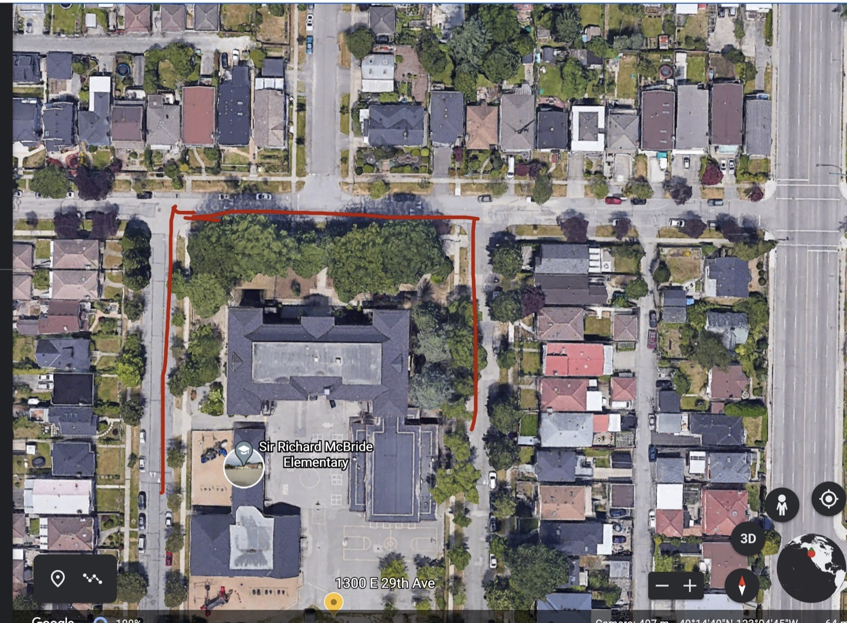
In the above photo you can see an aerial view of McBride. The AREA in front of the school is always a NO PARKING/STOPPING area. To the West is Culloden Street, this is a PICK UP/DROP OFF 5 MIN AREA. As well to the east on Henry Street, which is a PICK UP/DROP OFF 5 MIN AREA.
These zones are marked with signs that indicate clearly…there is not parking between 8am-5pm on Culloden and Henry street, and no stopping/idling on 29th Ave. THERE IS A 5 MIN MAX DROP OFF AND PICK UP IN THESE ZONES. (see below)

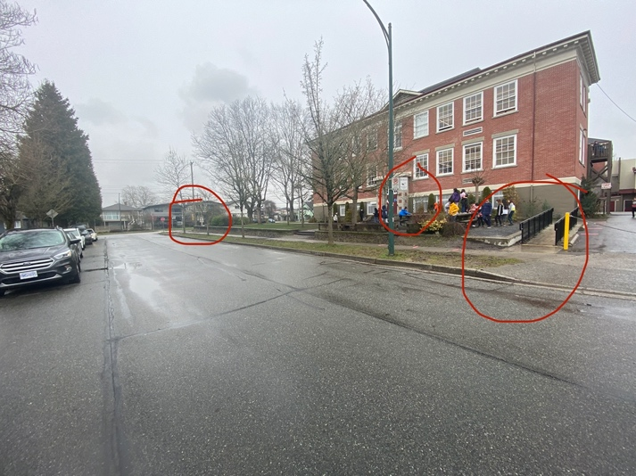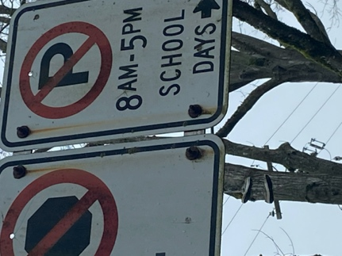
Culloden Street- the red circles denote the no parking longer than 5 mins between these signs. AS WELL, a wheelchair accessible exit ramp is located in this area.(Please note vehicles picking/dropping off students in wheelchairs are exempt from the no stopping/parking regulations for longer than the 5 min time limit.

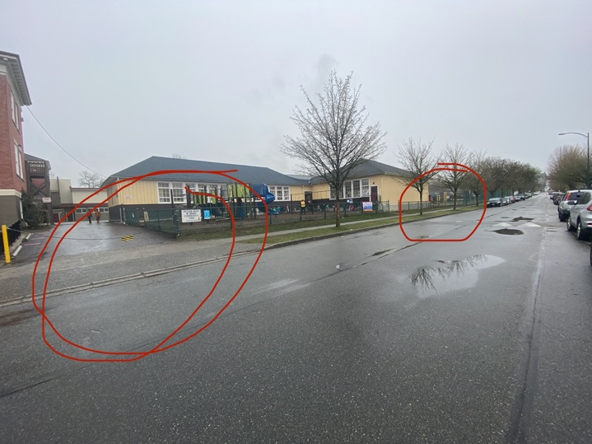
Culloden Street- the red circles denote the no parking for longer than 5 mins in between these signs. The chained area cannot be blocked as it is for fire trucks and emergency vehicles that might need access.

Recently the city of Vancouver has placed ramps to McBride on 29th, at the front of our school and will be adding two extra painted crosswalks from the corners of Mohawk to the front school sidewalk. (see below) However, this most likely won’t be completed until Spring. Please be aware that although you can park on the North side of 29th across from the school, there are certain lines you must park in. They will be more clearly painted; however, I have posted some photos so you will know NOT to park there.
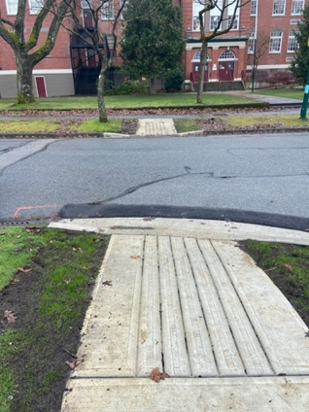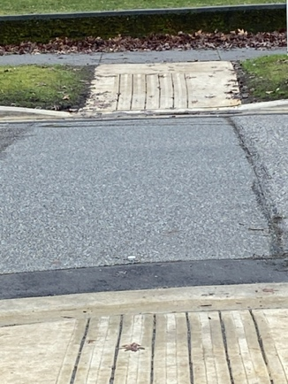
Corners of Mohawk and East 29th,
new ramps….crosswalk areas.
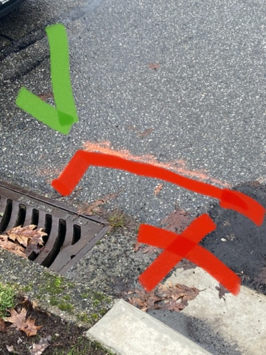 East Corner of Mohawk and 29th- must park behind red area- no stopping and idling in the red area as it blocks access and visibility to ramps and cross walk areas.
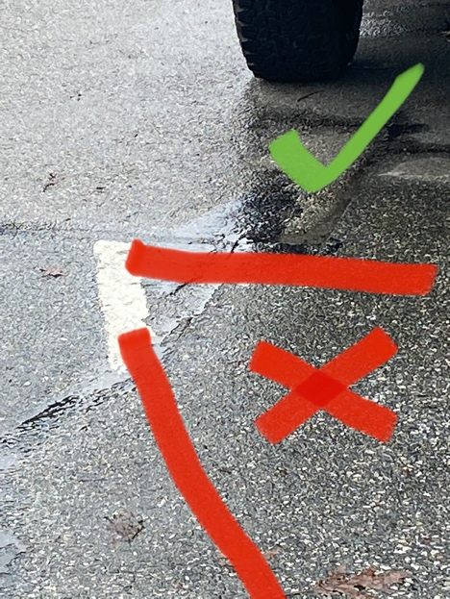 West Corner of Mohawk and 29th- must park behind red area- no stopping and idling in the red area as it blocks access and visibility to ramps and cross walk areas.

I know some parents feel this might be an inconvenience for them, we must act together as a community to keep our students safe. Please be aware of the all the traffic signs, as this is also a 30Km zone and follow the parking regulations. And be considerate of staff and volunteers when asked to move your vehicle.

